DATE | EVENT | SMSC Value | Intent
10th September | World Suicide Prevention Day | Moral | To highlight the importance of speaking to people and asking for help. To highlight key numbers and websites people can use when feeling down.
22nd September | National Fitness Day | Social | To develop an understanding of keeping healthy.
25th September | Macmillan Coffee Morning | Moral | To support and raise awareness of the wonderful work that Macmillan are renowned for.
26th September | European Day of Languages | Social | To raise awareness of different cultures and diversity.
3rd October | Black History Month  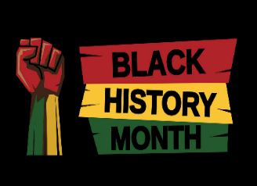 | Moral | To raise the importance of cultural diversity and to promote knowledge of black history, culture and heritage.
4th October | Harvest Festival | Spiritual | To understand the importance of harvest and learn ways in which we can support those in need.
SMSC Calendar
During the academic year our intent is to develop the spiritual, moral, social and cultural understanding of each pupil within Peregrinate. Key and special events have been planned that raise awareness for many meaningful causes and provides opportunities for the children to think about helping others by raising money for charities.

7th October | World Smile Day | Spiritual | To develop positive feelings and recognise the affect our actions have on others.
14th October | Diversity Day  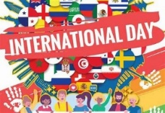 | Cultural | To promote different cultures and to raise awareness of our rich, beautiful and diverse world.
17th October | Festival of Diwali | Spiritual | To be accepting of diversity and culture.
18th October | Show Racism the Red Card | Moral | To raise the importance of showing racism the red card. To highlight the ethos of kindness and create to create responsible, caring citizens.
31st October | Halloween | Social | To promote the history of Halloween and keeping safe.
5th November | Guy Fawkes | Social | To understand the importance of keeping safe around fireworks.  To understand the history of Guy Fawkes.
11th November | Remembrance Day  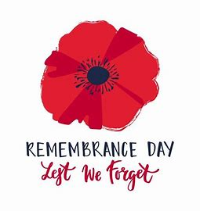 | Moral | To understand the importance of Remembrance Sunday and to pay respect to the service of others for their country.
14th – 18th November | Anti-bullying Week  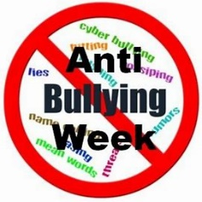 | Cultural | To embrace and celebrate the differences and similarities that make us special. To promote unity and encourage individual and collective action to stop bullying. To highlight the ethos of kindness and to create responsible, caring citizens.
14th November | Parliament Week  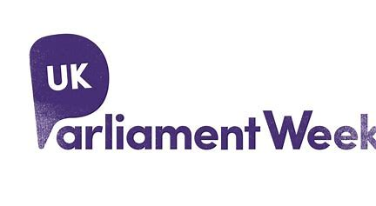 | Moral | To enrich the curriculum by teaching children about Parliament. This will help children learn about citizenship and democracy as part of their personal development.
19th November | Children in Need | Moral | To support and raise awareness of the wonderful work that Children in Need are renowned for.
December | Advent/ Christmas | Spiritual | To develop tolerance to the other beliefs of others. To reflect upon the true meaning of Christmas. To learn how Christmas is celebrated around the world.
12th December | Festival of Hannukah | Spiritual | To embrace diversity.
16th January | Chinese New Year | Cultural | To understand and accept diversity across the world.
1st February | LGBT+ History Month | Moral  Cultural  Social | To promote tolerance and raise  awareness of the prejudices faced by  lesbian, gay, bisexual and transgender  people.
6th February | Children’s Mental Health Week  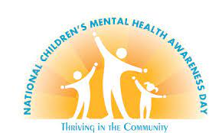 | Social | To understand the importance of looking after our mental health using the 5 ways of well-being.
7th February | Safer Internet Day | Moral  Cultural | On this day we will highlight the positive uses of technology and explore the role we all play in helping to make the internet a better and safer place for our community.
3rd March | World Book Day  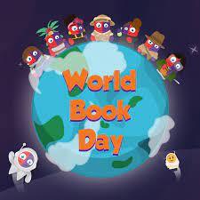 | Moral | To raise awareness of the Literary Books from the Past and Present. To promote the enjoyment gained from books.
8th March | International Women’s Day | Moral | To raise awareness for gender-equality.
13th March | Health Week | Social | To promote awareness of things that we can do to lead healthy lives.
21st March | Science Day | Social | To encourage the children to think about the importance of science in our everyday lives, whilst having fun.
31st March | Autism Awareness Day  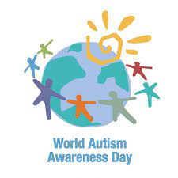 | Moral | To promote awareness of autism and how they impact the lives of many people. To teach children to be tolerant and inclusive of those that have different needs.
9th April | Easter | Social | To promote awareness of why Easter is celebrated and the religious aspects.
17th April | St George’s Day  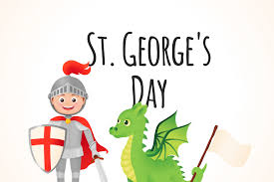 | Spirituality | To raise awareness of why St. George’s Day is celebrated in England.
21st April | Earth Day | Moral | To promote the importance of looking after our planet and environment.
1st May | Mayday  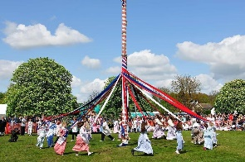 | Moral | To understand the history of Mayday and why is it celebrated.
17th May | Eid-Al-Fitr | Spiritual | To learn how different religions celebrate festivals. To develop tolerance towards different beliefs.
5th June | Well-being Afternoon | Social | To raise the importance of looking after our minds and bodies.
9th June | Make a difference day | Moral | To reflect on social and global issues that can impact
10th July | Geography Week | Social | To raise awareness of the importance pf having navigational skills.

