Personal Growth and Wellbeing
RSE & Health Education
KS4

Units Covered:
KS4PGW001 – Understanding Physical Health and Wellbeing
Including: Physical Health and Fitness P1
Healthy Eating P2
Drugs Alcohol and Tobacco P3, P4, P5
Health and Prevention P6
Changing Adolescent Body P7
KS4PGW002 – Understanding Emotional Wellbeing
Including: Mental Wellbeing P1, P2
KS4PGW003 – Recognising the Importance of Social Health and Wellbeing
Including: Families P1, P2
Respectful Relationships including friendships P3, P4, P5, P6, P7, P8
Intimate and Social Relationships inc. Sexual Health P9, P10, P11
KS4PGW006 – Recognising your rights and responsibilities
Including: The Law P1, P2
Basic First Aid P3, P4, P5, P6
KS4PGW008 – Becoming More Environmentally Aware
Including: Online and Media (*top up) P1
Being Safe (*top up) P2
Internet Safety and Harms (*top up) P2

*Top up units are covered throughout other topics with additional knowledge added here

Mandatory RSE & Health Education Content

Families
Pupils should know
• that there are different types of committed, stable relationships.
• how these relationships might contribute to human happiness and their importance for bringing up children.
• what marriage is, including their legal status e.g. that marriage carries legal rights and protections not available to couples who are cohabiting or who have married, for example, in an unregistered religious ceremony.
• why marriage is an important relationship choice for many couples and why it must be freely entered into.
• the characteristics and legal status of other types of long-term relationships.
• the roles and responsibilities of parents with respect to raising of children, including the characteristics of successful parenting.
• how to: determine whether other children, adults or sources of information are trustworthy: judge when a family, friend, intimate or other relationship is unsafe (and to recognise this in others’ relationships); and, how to seek help or advice, including reporting concerns about others, if needed.
Respectful relationships, including friendships
Pupils should know
• the characteristics of positive and healthy friendships (in all contexts, including online) including: trust, respect, honesty, kindness, generosity, boundaries, privacy, consent and the management of conflict, reconciliation and ending relationships.
This includes different (non-sexual) types of relationship.
• practical steps they can take in a range of different contexts to improve or support respectful relationships.
• how stereotypes, in particular stereotypes based on sex, gender, race, religion, sexual orientation or disability, can cause damage (e.g. how they might normalise non-consensual behaviour or encourage prejudice).
• that in school and in wider society they can expect to be treated with respect by others, and that in turn they should show due respect to others, including people in positions of authority and due tolerance of other people’s beliefs.
• about different types of bullying (including cyberbullying), the impact of bullying, responsibilities of bystanders to report bullying and how and where to get help.
• that some types of behaviour within relationships are criminal, including violent behaviour and coercive control.
• what constitutes sexual harassment and sexual violence and why these are always unacceptable.
• the legal rights and responsibilities regarding equality (particularly with reference to the protected characteristics as defined in the Equality Act 2010) and that everyone is unique and equal.
Online and media
Pupils should know
• their rights, responsibilities and opportunities online, including that the same expectations of behaviour apply in all contexts, including online.
• about online risks, including that any material someone provides to another has the potential to be shared online and the difficulty of removing potentially compromising material placed online.
• not to provide material to others that they would not want shared further and not to share personal material which is sent to them.
• what to do and where to get support to report material or manage issues online.
• the impact of viewing harmful content.
• that specifically sexually explicit material e.g. pornography presents a distorted picture of sexual behaviours, can damage the way people see themselves in relation to others and negatively affect how they behave towards sexual partners.
• that sharing and viewing indecent images of children (including those created by children) is a criminal offence which carries severe penalties including jail.
• how information and data is generated, collected, shared and used online.
Being safe
Pupils should know
• the concepts of, and laws relating to, sexual consent, sexual exploitation, abuse, grooming, coercion, harassment, rape, domestic abuse, forced marriage, honour-based violence and FGM, and how these can affect current and future relationships.
• how people can actively communicate and recognise consent from others, including sexual consent, and how and when consent can be withdrawn (in all contexts, including online).

Intimate and sexual relationships, including sexual health
Pupils should know
• how to recognise the characteristics and positive aspects of healthy one-to-one intimate relationships, which include mutual respect, consent, loyalty, trust, shared interests and outlook, sex and friendship.
• that all aspects of health can be affected by choices they make in sex and relationships, positively or negatively, e.g. physical, emotional, mental, sexual and reproductive health and wellbeing.
• the facts about reproductive health, including fertility, and the potential impact of lifestyle on fertility for men and women and menopause.
• that there are a range of strategies for identifying and managing sexual pressure, including understanding peer pressure, resisting pressure and not pressurising others.
• that they have a choice to delay sex or to enjoy intimacy without sex.
• the facts about the full range of contraceptive choices, efficacy and options available.
• the facts around pregnancy including miscarriage.
• that there are choices in relation to pregnancy (with medically and legally accurate, impartial information on all options, including keeping the baby, adoption, abortion and where to get further help).
• how the different sexually transmitted infections (STIs), including HIV/AIDs, are transmitted, how risk can be reduced through safer sex (including through condom use) and the importance of and facts about testing.
• about the prevalence of some STIs, the impact they can have on those who contract them and key facts about treatment.
• how the use of alcohol and drugs can lead to risky sexual behaviour.
• how to get further advice, including how and where to access confidential sexual and reproductive health advice and treatment.
The Law
Pupils should be made aware of the relevant legal provisions when relevant topics are being taught, including for example:
• marriage
• consent, including the age of consent
• violence against women and girls
• online behaviours including image and information sharing (including ‘sexting’,
youth-produced sexual imagery, nudes, etc.)
• pornography
• abortion
• sexuality
• gender identity
• substance misuse
• violence and exploitation by gangs
• extremism/radicalisation
• criminal exploitation (for example, through gang involvement or ‘county lines’
drugs operations)
• hate crime
• female genital mutilation (FGM)

Mental wellbeing
Pupils should know
• how to talk about their emotions accurately and sensitively, using appropriate vocabulary.
• that happiness is linked to being connected to others.
• how to recognise the early signs of mental wellbeing concerns.
• common types of mental ill health (e.g. anxiety and depression).
• how to critically evaluate when something they do or are involved in has a positive or negative effect on their own or others’ mental health.
• the benefits and importance of physical exercise, time outdoors, community participation and voluntary and service-based activities on mental wellbeing and happiness.
Internet safety and harms
Pupils should know
• the similarities and differences between the online world and the physical world, including: the impact of unhealthy or obsessive comparison with others online (including through setting unrealistic expectations for body image), how people may curate a specific image of their life online, over-reliance on online relationships including social media, the risks related to online gambling including the accumulation of debt, how advertising and information is targeted at them and how to be a discerning consumer of information online.
• how to identify harmful behaviours online (including bullying, abuse or harassment) and how to report, or find support, if they have been affected by those behaviours.

Physical health and fitness
Pupils should know
• the positive associations between physical activity and promotion of mental wellbeing, including as an approach to combat stress.
• the characteristics and evidence of what constitutes a healthy lifestyle, maintaining a healthy weight, including the links between an inactive lifestyle and ill health, including cancer and cardiovascular ill-health.
• about the science relating to blood, organ and stem cell donation.
Healthy eating
Pupils should know
• how to maintain healthy eating and the links between a poor diet and health risks, including tooth decay and cancer.
Drugs, alcohol and tobacco
Pupils should know
• the facts about legal and illegal drugs and their associated risks, including the link between drug use, and the associated risks, including the link to serious mental health conditions.
• the law relating to the supply and possession of illegal substances.
• the physical and psychological risks associated with alcohol consumption and what constitutes low risk alcohol consumption in adulthood.
• the physical and psychological consequences of addiction, including alcohol dependency.
• awareness of the dangers of drugs which are prescribed but still present serious health risks.
• the facts about the harms from smoking tobacco (particularly the link to lung cancer), the benefits of quitting and how to access support to do so.

Health and prevention
Pupils should know
• about personal hygiene, germs including bacteria, viruses, how they are spread, treatment and prevention of infection, and about antibiotics.
• about dental health and the benefits of good oral hygiene and dental flossing, including healthy eating and regular check-ups at the dentist.
• (late secondary) the benefits of regular self-examination and screening.
• the facts and science relating to immunisation and vaccination.
• the importance of sufficient good quality sleep for good health and how a lack of sleep can affect weight, mood and ability to learn.
Basic first aid
Pupils should know
• basic treatment for common injuries.
• life-saving skills, including how to administer CPR.
• the purpose of defibrillators and when one might be needed.
Changing adolescent body
Pupils should know
• key facts about puberty, the changing adolescent body and menstrual wellbeing.
• the main changes which take place in males and females, and the implications for emotional and physical health.

Personal Growth and Wellbeing

KS4

KS4PGW001

Understanding Physical Health and Wellbeing
RSE & PSHE

Learner Name:
Date Started:
Date Completed:

Tutor Name:
Tutor Feedback:
……………………………………………………………………………………………………………………………………………………………………………………………………………………………………………………………………………………………………………………………………………………………………………………………………………………………………………………………………………………………………………………………………………………………………………………………………………………
List some forms of Physical Activity/Exercise and describe their benefits underneath:
1)………………………………………………………… A
……………………………………………………………………………………………………………………………………………………………………………………………………
2)………………………………………………………….
……………………………………………………………………………………………………………………………………………………………………………………………………
3)…………………………………………………………..
…………………………………………………………………………………………………………………………………………………………………………………………………….
What would happen to your body if you sustained a diet of water and lettuce?
…………………………………………………………………………………………………………………………………………………………………………………………………….
What would happen to your body if you sustained a diet of fast food? (Supersize Me)
…………………………………………………………………………………………………………………………………………………………………………………………………….
ACTIVITY – On separate paper
Draw a plate with a square meal on it. It could be your favourite, it could be something you like, or you could suggest a meal for somebody looking to maintain their healthy body weight.
HINT – think about food groups!

Food serves a purpose other than tasting great…
This is known as nutrition.
Your body needs certain food types to carry out certain functions, describe them below:
Protein: ………………………………………………………………………………….
Fat: ………………………………………………………………………………………
Carbohydrate: …………………………………………………………………………..
Fibre: ……………………………………………………………………………………..
Dairy: ……………………………………………………………………………………..
Now that you know what happens if you eat unhealthy for a period of time, can you list some risks that come with being overweight or obese?
1)……………………………………………………………………………………………….
2)……………………………………………………………………………………………….
3)……………………………………………………………………………………………….

Some foods can damage your body in other ways.
Try and complete the table below, you may want to discuss this with your tutor and classmates:

Harmful Food | Damage Caused
Sugar

Saturated Fat
Salt
B
If you want to change you physical appearance or improve health and wellbeing you should monitor your progress. Give some examples of how to do this:
…………………………………………………………………………………………………..
Set a health or fitness goal you could improve: (Don’t worry, you don’t have to do it!)
…………………………………………………………………………………………………..
Step 1 of monitoring:………………………………………………………………………….
Step 2 of monitoring:………………………………………………………………………….
Step 3 of monitoring:………………………………………………………………………….
Step 4 of monitoring:………………………………………………………………………….

ACTIVITY – On separate paper
Pretend you work in a doctors or dentist and make an informative leaflet to leave in your waiting room.
It should include:
- Relevant risks (Sugar = tooth decay or saturated fats = heart disease/strokes)
- Advice on how to avoid these dangers
- Alternatives to full sugar/ full fat foods and drinks
- Advice on where to find support or who to talk to if you are worried
Throughout our lives there may be occasions where we are given drugs to benefit our health and wellbeing.
Can you name some drugs that the doctor may give you?
…………………………………………………………………………………………………………………………………………………………………………………………………….

Sometimes drugs are used without the doctor’s consent, and for reasons other than to benefit our health.
As a group, discuss types of recreational drugs, the affects you know about and the risks, make notes below:
DRUG TYPE | METHOD OF TAKING | AFFECTS | RISKS
Tobacco
Alcohol

Some drugs are legal, put a star (*) or a tick next to the drugs named above that are currently LEGAL in the UK.
As a group, discuss types of legal drugs, why people take them and where they come from:
DRUG NAME | METHOD | SOURCE | BENEFIT
Paranoia – Definition
a mental condition characterized by delusions of persecution, unwarranted jealousy, or exaggerated self-importance, typically worked into an organized system.
Some drugs can make people paranoid.
Can you describe a situation where somebody may be paranoid due to drug use?
……………………………………………………………………………………………………………………………………………………………………………………………………..
Can you name any other drugs that may make somebody feel paranoid?
…………………………………………………………………………………………………

Addiction – Definition
the fact or condition of being addicted to a particular substance or activity.
Other than physically needing to use the drug, what other behaviours may come with addiction?
……………………………………………………………………………………………………………………………………………………………………………………………………
Alcohol can be abused just like any drug, known as binge drinking, but there are ways to drink safely.
Can you think of any ways to stay safe while drinking?
……………………………………………………………………………………………………………………………………………………………………………………………………
Some substances are more readily available than others.
For instance, supermarkets will never run out of alcohol or cigarettes and are usually open 24 hours a day.
For this reason, people find it quite easy to become dependent on these substances.
What does ‘dependant’ mean?
…………………………………………………………………………………………………..
How do you think people in dependency feel when they have no alcohol, tobacco or drugs?
………………………………………………………………………………………………………………………………………………………………………………………………………………………………………………………………………………………………………

When we talk about drugs that are legal, we mean drugs that are given by doctors or can be purchased.
This does not mean that they are SAFE.
Drugs from the doctor have a list of instructions and a person’s name on the box, if that person takes the drugs as described they will be somewhat safe, although there will still be a list of side effects inside the box.
What may happen if somebody else takes prescription tablets? Or takes more than instructed?
……………………………………………………………………………………………………………………………………………………………………………………………………

Smoking is going out of fashion. Less people are smoking cigarettes, tobacco and cannabis.
Why do you think this is?
……………………………………………………………………………………………………………………………………………………………………………………………………
People who have quit smoking have reported lots of benefits.
Can you describe some?
……………………………………………………………………………………………………………………………………………………………………………………………………

If you want support to quit smoking you can speak to your doctor or:
You can access NHS help at https://www.nhs.uk/live-well/quit-smoking/
Or
You can speak to Addaction/WeAreWithYou at https://www.wearewithyou.org.uk/

ACTIVITY –
Write a letter to a friend, relative or somebody you know asking them to stop smoking.
You should:
- Explain why you want them to quit
- Explain how they will benefit
- Explain how you will benefit
- Give them some facts to persuade them to quit
- Suggest where they may get help if they find it difficult
Who remembers Covid-19?
What did we learn about germs, bacteria, virus and infection?
………………………………………………………………………………………………………………………………………………………………………………………………………………………………………………………………………………………………………
Throughout the Covid-19 pandemic the NHS performed millions of vaccinations. Why did they do that?
…………………………………………………………………………………………………..
Other than Covid-19, can you think of any other time when you may be given immunisations?
…………………………………………………………………………………………………..
What can you and who can help if you have an infection?
(chest, throat, eye or sexual)
……………………………………………………………………………………………………………………………………………………………………………………………………
This is a picture of an infected tooth:
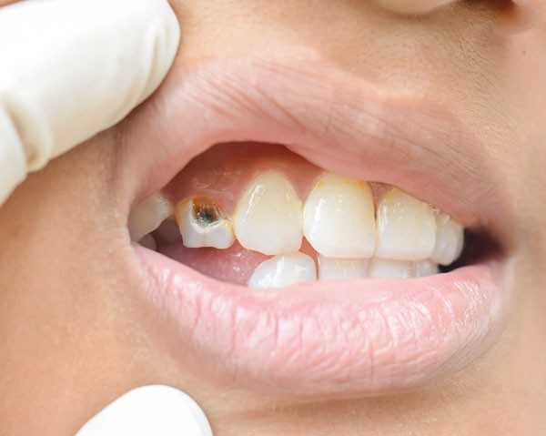
How can oral infections be prevented?
1)…………………………………………
2)…………………………………………
3)…………………………………………
4)…………………………………………

The NHS advises all adults to examine their own bodies and attend screening appointments.
Both males and females can find information on this here:
https://www.cuh.nhs.uk/patient-information/
What are the benefits of checking yourself out and allowing your doctor to perform screening?
…………………………………………………………………………………………………
Can you describe how you have felt when you haven’t had enough sleep?
…………………………………………………………………………………………………..
Now that you have an understanding of the nutrition, rest and activity your body needs to function properly, and the impact of drugs on your body, it is time to look at the changes your body takes throughout the process of puberty.
You covered some points about puberty in Key Stage 3, so let’s recap what you know with a little quiz:
What age does puberty usually start?...........................................................................
What happens to males during puberty?.......................................................................
What happens to females during puberty?....................................................................
What are post-pubescent people capable of?...............................................................
Does everybody reach puberty at the same time?........................................................

Well remembered!

When females go through puberty, they begin a Menstrual Cycle.
How long does a cycle usually last?.......................................................
How may a female’s feelings change throughout this cycle?
…………………………………………………………………………………………………..
What can we do to show we understand somebody’s feelings?
…………………………………………………………………………………………………..
If a cycle is missed, or late, what might this be a sign of?
…………………………………………………………………………………………………..

Young people may experience higher risk of mental health issues with early puberty. Those most frequent in the teenage years include anxiety and depression, eating disorders, conduct disorder (serious antisocial behaviour), attention deficit and hyperactivity disorder (ADHD) and self-harm.

ACTIVITY – On separate paper

Create a mood board that indicates a change: (One feeling to another)
- Show some feelings you are familiar with
- Show what makes you feel that way
- Show what makes you feel better

Personal Growth and Wellbeing

KS4

KS4PGW002

Understanding Mental Wellbeing
RSE & PSHE

Learner Name:
Date Started:
Date Completed:

Tutor Name:
Tutor Feedback:
……………………………………………………………………………………………………………………………………………………………………………………………………………………………………………………………………………………………………………………………………………………………………………………………………………………………………………………………………………………………………………………………………………………………………………………………………………………
Add words to each circle to explain what may make you feel that way:
SAD

HAPPY

Now do your own:

Who can you talk to about your feelings?
…………………………………………………………………………………………………..
How do you feel after you haven spoken to your favourite people?
…………………………………………………………………………………………………..
If you shout at people, or are angry and aggressive, how will they react?
…………………………………………………………………………………………………
Where do you go, or what do you do when you want to be happy?
…………………………………………………………………………………………………..
Would you do this on your own, or prefer to be with somebody else?
…………………………………………………………………………………………………..
Why do you think this is?
…………………………………………………………………………………………………..
What are the signs you, or somebody else may be becoming mentally unwell?
……………………………………………………………………………………………………………………………………………………………………………………………………
What can you do if you feel like this, or see somebody feeling this way?
……………………………………………………………………………………………………………………………………………………………………………………………………
Some aspects of mental health are natural, your body’s way of giving you a message.
Can you describe a time when you have had a feeling, maybe in your stomach, that something isn’t right?
……………………………………………………………………………………………………………………………………………………………………………………………………
That is your body’s first way of keeping you safe, after that you may reach fight, flight or freeze is danger continues or escalates.
Can you imagine having that feeling ALL OF THE TIME?
That would be called anxiety. When people talk about anxiety they often link it to depression.
If somebody is depressed they have been feeling sad for some time. They may not enjoy things they used to enjoy or going to places they used to love.
What can you do for somebody who has anxiety or depression?
Anxiety:…………………………………………………………………………………………Depression:………………...………………………………………………………………….
Describe a time when you have been involved in something that affected your A mental health, or made you worry:
……………………………………………………………………………………………………………………………………………………………………………………………………
Describe a time when you have been involved in something that affected somebody else’s mental health, or made you worry:
……………………………………………………………………………………………………………………………………………………………………………………………………
When we feel down we can tackle it by getting involved in some FEEL GOOD B activities such as:
…………………………………….. ……………………………………..
…………………………………….. ……………………………………..
…………………………………….. ……………………………………..

Personal Growth and Wellbeing

KS4

KS4PGW003

Recognising the Importance of
Social Health and Wellbeing
RSE & PSHE
Learner Name:
Date Started:
Date Completed:

Tutor Name:
Tutor Feedback:
……………………………………………………………………………………………………………………………………………………………………………………………………………………………………………………………………………………………………………………………………………………………………………………………………………………………………………………………………………………………………………………………………………………………………………………………………………………
On your own,
Can you give some nouns that mean someone you may be in a romantic relationship with?
1)………………………………………………………………
2)………………………………………………………………
3)………………………………………………………………
4)………………………………………………………………
After you have discussed your thoughts with your tutor and the group, write a bit about what you think makes the relationships with people you have named above romantic?
………………………………………………………………………………………………………………………………………………………………………………………………………………………………………………………………………………………………………
On your own,
List some factors that make intimate/romantic relationships healthy?
1)…………………………………………………………………..
2)…………………………………………………………………..
3)…………………………………………………………………..
4)…………………………………………………………………..
After you have discussed your thoughts with your tutor and the group, is there anything else you can think of?
……………………………………………………………………………………………………………………………………………………………………………………………………………………………………………………………………………………………………….

ACTIVITY – On separate paper
Make an information leaflet or a flyer that advice young people what to ensure is in their relationship (trust, honesty, respect) and what to avoid (lies, pressure, threats)
In KS3 you covered the concept of marriage.
Can you name and describe other types of committed, stable relationships?
1)………………………………………
…………………………………………………………………………………………………
2)……………………………………….
…………………………………………………………………………………………………How might a stable relationship contribute to happiness?
…………………………………………………………………………………………………
How do stable relationships impact the upbringing children receive?
…………………………………………………………………………………………………
What legal rights do legally married people have that other couples don’t?
……………………………………………………………………………………………………………………………………………………………………………………………………..
Why do so many people think marriage is important?
……………………………………………………………………………………………………………………………………………………………………………………………………
Give an example of an occasion when someone may be married against their will, and what may happen if somebody is forced to marry?
………………………………………………………………………………………………………………………………………………………………………………………………………………………………………………………………………………………………………
If a couple starts a family (has, fosters or adopts children) what responsibilities do they have?
……………………………………………………………………………………………………………………………………………………………………………………………………………………………………………………………………………………………………….
Can you think of any signs that the parents are bringing the children up successfully?
………………………………………………………………………………………………………………………………………………………………………………………………………………………………………………………………………………………………………
Tell us some things you think your parents/guardians have done well in your life, or some things you are grateful for:
…………………………………………………………………………………………………………………………………………………………………………………………………………………………………………………………………………………………………………………………………………………………………………………………………………

Sometimes people are not trustworthy. This means they may say, write or share something that is untrue or incorrect. They may do this to coerce you to do something or go somewhere you usually wouldn’t. They may do this to change how you think or feel and you may find yourself in an unsafe situation.
Read the messages below and explain if you would be worried about your friend or relative who sent you these messages:
1)……………………………………………………………
I am going to town after School, I met a guy on the bus this morning who said he would take me shopping when he finishes work. If my mum asks will you tell her I am in yours doing homework?
Thanks for being a friend!

………………………………………………………………
………………………………………………………………
………………………………………………………………
………………………………………………………………
………………………………………………………………

2)……………………………………………………………
What you up to on Sat?
That girl from last week said her mum is cool about us sitting off in hers again!
She was in the kitchen with her mates all night, defo on drugs but at least she left us alone upstairs…

………………………………………………………………
………………………………………………………………
………………………………………………………………
………………………………………………………………
………………………………………………………………

3).…………………………………………………………
Can you walk home with me again today?
My uncle keeps trying to pick me up in his car but his friends are super creepy…
If you and Meg walk with me there won’t be room in the car.

………………………………………………………………
………………………………………………………………
………………………………………………………………
………………………………………………………………
………………………………………………………………

If the people discussed in these messages were completely trustworthy they would have acted differently? How?
………………………………………………………………………………………………………………………………………………………………………………………………………………………………………………………………………………………………………………………………………………………………………………………………………….
Can you point out anything from the three messages on the previous page that may indicate a disrespectful friend?
……………………………………………………………………………………………………………………………………………………………………………………………………What could these people have done differently to be more respectful?
……………………………………………………………………………………………………………………………………………………………………………………………………
Imagine you received message 1. Your friend has ‘put you on the spot’ and asked for something you know may be dangerous.
what would you reply to try and make your friend have some more respect for you?

Can you think of anything else you could do to keep your friend safe?
……………………………………………………………………………………………………………………………………………………………………………………………………
What could go wrong for the person who sent message 1?
……………………………………………………………………………………………………………………………………………………………………………………………………………………………………………………………………………………………………….
What could go wrong for the person who sent message 2?
………………………………………………………………………………………………………………………………………………………………………………………………………………………………………………………………………………………………………
What could go wrong for the person who sent message 3?
………………………………………………………………………………………………………………………………………………………………………………………………………………………………………………………………………………………………………
When you read message 1, what do you think you learnt about the ‘guy from the bus’?
1)………………………………………………………………………………………………..
2)………………………………………………………………………………………………..
3)……………………………………………………………………………………………….
If you told your friend’s parents that they were going to town to meet an older man, what would they do?
……………………………………………………………………………………………………………………………………………………………………………………………………
What if… (discuss)
What if the ‘man’ was the same age but taking part in work experience?
What if your friend was 16 and the ‘man’ was 17, on an apprenticeship?
What if your friend had sat next to the ‘man’ every day for a long time and had got to know him quite well?
Circle as appropriate;
Did you read the message as though it came from a BOY or a GIRL?

Would you think differently if it was the other way around?
………………………………………………………………………………………………………………………………………………………………………………………………………………………………………………………………………………………………………..

We all make presumptions when we read things or meet people.
As soon as we see somebody our brain makes initial judgements based on what we see; sex, gender, race, religion, sexual orientation or disability.
Sometimes, we may act in a certain way based on our initial judgement and then later find out we were wrong or mistaken.
For example, it is impossible to state somebody’s sexual orientation or exact age just by looking at somebody, but there are some characteristics that we can see and instantly know something about that person. Can you name some?
1)……………………………………………………………………………………………..
2)……………………………………………………………………………………………..
3)……………………………………………………………………………………………..

When you walk in to school, you are covered by and must adhere to our RESPECT Policy.
This means that respect is given at all times, to you, and hopefully by you.
We don’t care what colour your skin is, about any disabilities or difficulties, who you are attracted to or if you follow any particular religion.
You will be treated with the same respect regardless.
Sometimes, in the community, you may not receive the same level of respect, or you may witness somebody being treated disrespectfully.
Can you describe a situation where this has happened?
…………………………………………………………………………………………………………………………………………………………………………………………………………………………………………………………………………………………………………………………………………………………………………………………………………
How did this make you feel?
…………………………………………………………………………………………………………………………………………………………………………………………………………………………………………………………………………………………………………………………………………………………………………………………………………
Is there anything that could prevent this happening in future?
…………………………………………………………………………………………………………………………………………………………………………………………………………………………………………………………………………………………………………………………………………………………………………………………………………
Our School has an Anti-Bullying Policy which lists the following types of bullying that may take place. Please give examples of each type:
- Physical:……………………………………………………………………………….
- Verbal:………………………………………………………………………………….
- Exclusion:………………………………………………………………………………
- Emotional:……………………………………………………………………………...
- Sexual:…………………………………………………………………………………
- Damage/theft:………………………………………………………………………….
- Cyber:…………………………………………………………………………………..
What can you do if you are being bullied?
………………………………………………………………………………………………………………………………………………………………………………………………………………………………………………………………………………………………………
Can you think of any reasons people may not report bullying?
………………………………………………………………………………………………………………………………………………………………………………………………………………………………………………………………………………………………………
What can you do if you witness someone being bullied?
………………………………………………………………………………………………………………………………………………………………………………………………………………………………………………………………………………………………………
Can you think of any bullying that may take place within a relationship?
………………………………………………………………………………………………………………………………………………………………………………………………………………………………………………………………………………………………………
Sometimes bullying can cross the line and become illegal rather than just unpleasant. Can you describe when?
………………………………………………………………………………………………………………………………………………………………………………………………………………………………………………………………………………………………………
If bullying or assault happens more than once it may be classed as harassment.
With this in mind, can you describe what sexual harassment is?
……………………………………………………………………………………………………………………………………………………………………………………………………
Sometimes, ‘types of bullying’ may be mixed together. Can you explain some ways this may happen?
……………………………………………………………………………………………………………………………………………………………………………………………………
‘Sexual Violence’ is a term that is used commonly when talking about abuse. Can you explain what this is and why it is unacceptable?
………………………………………………………………………………………………………………………………………………………………………………………………………………………………………………………………………………………………………
When we talk about respect, bullying and treating people equally we often hear the word ‘equality’

What does equality mean?
………………………………………………………………………………………………………………………………………………………………………………………………………………………………………………………………………………………………………
In the UK we take equality very seriously.
In fact, there is a law to make sure everybody takes it seriously.
It’s called the Equality Act 2010 and it ensures that everybody is treated equally.
In order to ensure that the law is easy to understand there are a list of characteristics that are protected.
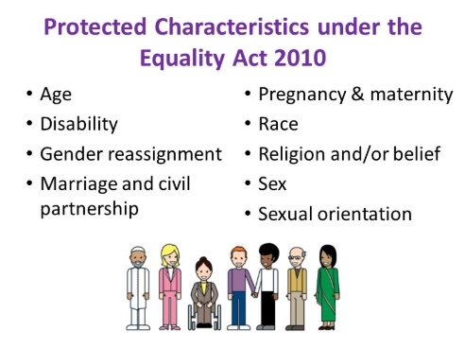

Please describe a situation where somebody may now benefit from the Equality Act, they may not have done before:
………………………………………………………………………………………………………………………………………………………………………………………………………………………………………………………………………………………………………
Can you give an example of a stereotype?
……………………………………………………………………………………………………………………………………………………………………………………………………
How might this be used unfairly, in a negative way or be destructive?
……………………………………………………………………………………………………………………………………………………………………………………………………..
What about in a sexual nature?
……………………………………………………………………………………………………………………………………………………………………………………………………

How can sexual choices affect your:
Physical Health:
…………………………………………………………………………………………………..Emotional Wellbeing/Mental Health:
…………………………………………………………………………………………………..
Sexual Health:
…………………………………………………………………………………………………

Explain how other choices can affect your fertility:
…………………………………………………………………………………………………..

Can you think of any reasons people may have sex when they don’t want to?
……………………………………………………………………………………………………………………………………………………………………………………………………
How can you avoid peer pressure?
…………………………………………………………………………………………………………………………………………………………………………………………………….
Who decides when you should have sex, and who with?
………………………………………………………………………………………………….
How can you maintain a relationship without having sex?
…………………………………………………………………………………………………..
…………………………………………………………………………………………………..
When you do decide to have sex, there are ways to keep yourself safe and prevent pregnancy. What are they?
1)……………………………….. 2)………………………………….
3)……………………………….. 4)………………………………….
Which of these options prevent against STDs and STIs?
…………………………………………………………………………………………………..
You can get contraception and advice from the chemist, family planning clinics or:
https://www.gettingiton.org.uk/contraception

You have already covered the science of pregnancy. (Sperm and Egg, remember?)
Unfortunately, there is a lot of factors that may affect the development and birth of a healthy baby and sometimes babies do not survive the full term of the pregnancy, this is called a ……………………………..
This may be because:
………………………………………….. …………………………………………..
………………………………………….. …………………………………………..
………………………………………….. …………………………………………..
If you are pregnant there are options available. Not everybody is ready, or capable, of being a parent.
Describe each option below:
Abortion: ……………………………………………………………………………………..
Adoption: ……………………………………………………………………………………..
Keeping the baby: ……………………………………………………………………………
If you are very young, unwell or unable to provide care you may be informed that keeping the baby is not an option.
How can the use of Alcohol and drugs may affect:
A male: ……………………………………………………………………………………….
A female: ……………………………………………………………………………………..
An unborn baby: ……………………………………………………………………………..
If you would like advice about fertility and reproduction you can speak to your doctor or:
The Fertility Department, Liverpool Women’s Hospital 0151 702 4121
When you have sex you are at risk of contracting STIs such as:
………………………………………….. …………………………………………..
………………………………………….. …………………………………………..
………………………………………….. …………………………………………..
You can reduce this risk by…………………………………………………………………..
If you have an STI you may notice:
………………………………………….. …………………………………………..
………………………………………….. …………………………………………..
………………………………………….. …………………………………………..
If you do notice any of these symptoms, you can get tested by:
Axess Liverpool, University Hospital, The Royal, Prescot St, Liverpool L7 8XP, 0800 323 1300
Axess Knowsley, 2 Ellison Grove, Huyton, Liverpool L36 9GA, 0800 323 1300
Sefton Sexual Health, St. Hugh's Building, Stanley Road, Bootle L20 3QQ, 01695 656550

Some tests are carried with an oral ……………..
Some tests are carried out with a blood ……………….
Some tests are carried out with a genital ………………
Some tests are carried out with a urine …………………
And some tests are carried out by taking a sample of ……………………..

ACTIVITY –
Your friend sends you this message:

Hey, I’m a bit worried…
We stayed in my sister’s house last week and IT happened. I have been feeling really uncomfortable down there and want to go to the clinic but I don’t know where it is and I’m scared to go on my own!

Now that you are clued up, advise them where they need to go and what may happen, reassure your friend that you will go with them and explain how to make sure this doesn’t happen again!
Now that you have helped your friend… B
Can you list some qualities that you would look for in a friend?

The Ideal Friend

Choose three of those qualities and explain how you can make sure you do this for your friends:
1)………………………………………………..
……………………………………………………………………………………………………………………………………………………………………………………………………
2)…………………………………………………
…………………………………………………………………………………………………………………………………………………………………………………………………….
3)………………………………………………….
……………………………………………………………………………………………………………………………………………………………………………………………………

Can you explain how some of these qualities help keep you and your friends safe? A
……………………………………………………………………………………………………………………………………………………………………………………………………..

Can you explain how good friendships impact your health and wellbeing?
………………………………………………………………………………………………………………………………………………………………………………………………………………………………………………………………………………………………………

Personal Growth and Wellbeing

KS4

KS4PGW006

Recognising your Rights and Responsibilities
RSE & PSHE

Learner Name:
Date Started:
Date Completed:

Tutor Name:
Tutor Feedback:
……………………………………………………………………………………………………………………………………………………………………………………………………………………………………………………………………………………………………………………………………………………………………………………………………………………………………………………………………………………………………………………………………………………………………………………………………………………
Sometimes, your rights and responsibilities are set out in law.
You have covered the law in relationship to some topics throughout your PGW sessions.
In this section we will recap what you know and link it all together so you can find it easily in future.
Marriage:
You need to be …….. years of age to legally marry.
A marriage that ends within …… years is legally classed as a ‘short term’ marriage, this means that partners will have less entitlement to ……………………… and ……………………… .
After 5 years, UK courts aim to settle divorces with assets being split ….. / …. .
Consent:
The age of consent in England and Wales is …. .
This is when a person of any sex, gender or ………………………… can consent to taking part in ……………………. activity.
Laws on sex, sexual imagery/videos or conversations have different
Certain circumstances make it impossible for a person to legally give consent. Often this is when a person is not mentally or physically capable of choosing whether or not to engage in sexual behaviour.
For instance, if someone is ……… or high on drugs then that person cannot give consent. This means that even if someone seems eager to engage in sexual activity, doing so can legally be considered sexual assault or ……….. .
Online Behaviours:
Making threats, blackmailing, being abusive/offensive or calling names may be legally classed as …………………………………. communications. People found guilty of malicious communications may receive a court order, a fine or even go to …………………… .
Sexual imagery, nudes and videos of people under the age of …….. are illegal to take, ……………. , or even ask for.
If you ……………. An indecent image of somebody under …… you have created an indecent image of a minor.
If you …………… , or are sent and indecent image of somebody under …… without reporting it to the Police you are guilty of sharing/possessing indecent images of a minor.
If you ask a person under ……. to send you an indecent image you are guilty of enticing a minor to engage in ………………………. Activity.
Abortion:
An abortion can be carried out ………………….. 24 weeks of pregnancy…
UNLESS! The ……………………… life would be at risk to continue the pregnancy OR the child would be born with a ……………………….. disability.
Sexuality:
The law which makes it legal for LGBTQ couples to consent to sex from the age of 16 was only introduced in …………….. . Before this, consent in the LGBTQ community wasn’t legal until the age of 18, and 21 before that.
Sexuality is also a …………………… characteristic as defined by the ………………. Act.
Gender Identity:
The Gender ……………………………. Act allows a person to change their legally recognised gender. To do this they must obtain a ……………………………………
………………………………. .

Substance Misuse:
Drugs are categorised in ‘classes’… class A, class B and class C
Cannabis is a Class …. Drug. Cocaine is a Class …. Drug.
Heroin is a Class …. Drug. Ketamine is a Class …. Drug.
Ecstasy is a Class …. Drug. Speed is a Class …. Drug.
Possession of a class A drug may come with an ….…………. fine and up to …. years in prison.
Possession of a class B drug may come with an …………..… fine and up to …. years in prison.
Possession of a class C drug may come with an …………..… fine and up to …. years in prison.
Sentences can ……………………. If you are ………………. Or ……………. drugs.
Hate Crime:
The law recognises five types of hate crime on the basis of: Race, Religion, Disability, Sexual orientation, Transgender identity.
You may be found guilty of a hate crime if your are found to demonstrate …………… towards one of the groups listed, or if your actions are …………………….. by hostility towards any of the groups listed.

As a human being it could be argued that it is everybody’s responsibility to help each other when in need, for instance, if you come across somebody who is hurt or unwell.
The first thing you need to do if you find somebody hurt, injured or unwell is check the area for any danger. What dangers might you find?
……………………………………………………………………………………………………………………………………………………………………………………………………
If the person is not breathing or conscious, you should dial 999 immediately and ask for an ambulance. What do you need to tell the call handler?
……………………………………………………………………………………………………………………………………………………………………………………………………..
If the person is unconscious, you should lay them in the recovery position:
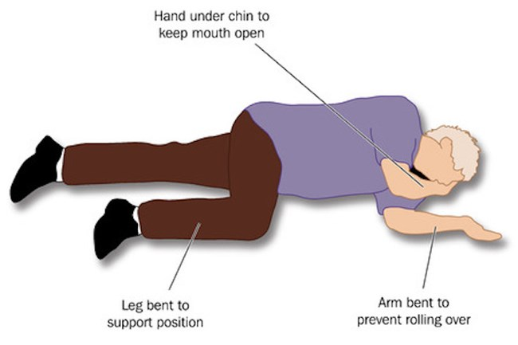
Why don’t your try it on your classmates?
If there is any injuries to the head you should …………………………………………….
If there is excessive bleeding you should ………………………………………………….
If somebody is burnt or scalded you should ……………………………………………….

If somebody has a small cut, abrasion, or laceration WITH NO DEBRI you may be able to apply a bandage.

ACTIVITY –
Draw a cut, abrasion, or laceration on your arm.
Ask a classmate to:
- Clean it with a sterile wipe (pretend if you have to)
- Apply wadding
- Wrap with a bandage with enough pressure to stop bleeding
There are some things we can treat ourselves, if the injury is not too serious, to save the NHS, ambulance service and professional resources.
Common Injuries | Basic Treatment
Bleeding

Mild Choking

Abrasion

Describe how these injuries may occur:
Bleeding: ……………………………………………………………………………………… …………………………………………………………………………………………………..
Mild Choking: ………………………………………………………………………………… ………………………………………………………………………………………………….
Abrasion: ……………………………………………………………………………………… …………………………………………………………………………………………………..
If you find somebody is not breathing normally or may have had a heart attack you can perform cardiopulmonary resuscitation. Also known as …. …. …. .
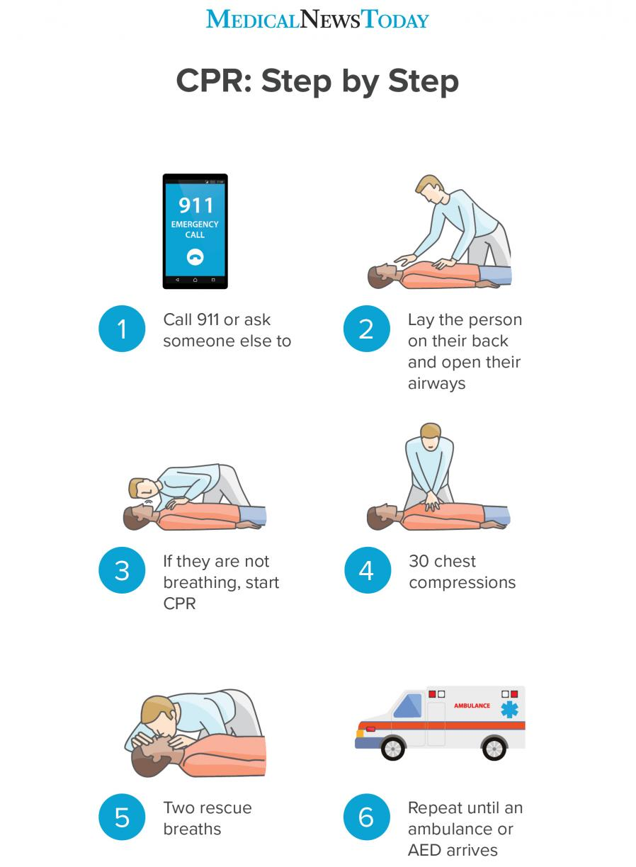

TIPS:
-Use your body weight, not just arms
-When you release, allow chest to return to normal position
-100-120 compressions per minute

If you do not feel confident to give rescue breaths you can continue with ‘hands only CPR’

Raising the patients chin will make rescue breaths more affective.

You can only do your best until the professionals arrive.

If somebody is in cardiac arrest (Chest pain or discomfort, Heart palpitations, Rapid or irregular heartbeats, Unexplained wheezing, Shortness of breath) you may be able to use a …………………………….. or …………….. .
If you're on your own, don't interrupt CPR to go and find a defibrillator. If it's possible, send someone else to find one. When you call 999, the operator can tell you if there's a public access defibrillator nearby.
To use a defibrillator, follow these simple steps:
Step 1: Turn the defibrillator on by pressing the green button and follow its instructions.
Step 2: Peel off the sticky pads and attach them to the patient’s skin, one on each side of the chest, as shown in the picture on the defibrillator.
Step 3: Once the pads have been attached, stop CPR and don’t touch the patient. The defibrillator will then check the patient’s heart rhythm.
Step 4: The defibrillator will decide whether a shock is needed and if so, it will tell you to press the shock button. An automatic defibrillator will shock the patient without prompt. Don’t touch the patient while they are being shocked.
Step 5: The defibrillator will tell you when the shock has been delivered and whether you need to continue CPR.
Step 6: Continue with chest compressions until the patient shows signs of life or the defibrillator tells you to stop so it can analyse the heartbeat again.
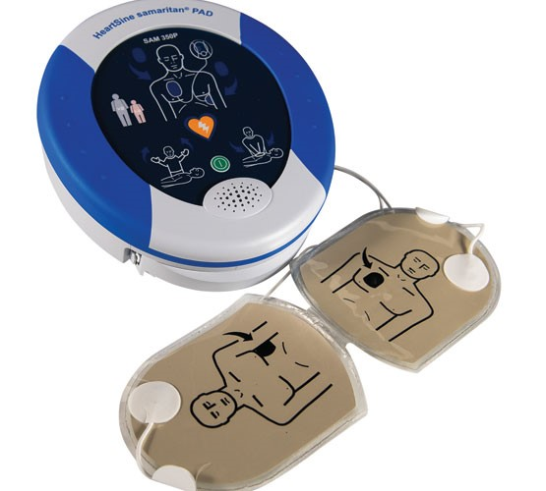
REMEMBER: Anyone can use a defibrillator and you don’t need training. Once you turn it on, it will give clear instructions on how to attach the defibrillator pads. The device checks the heart rhythm and will only tell you to shock if it’s needed. You can't shock someone accidentally.

ACTIVITY – On the next page

Label the torso with the locations of:
- Where your would put your hands for CPR
- Where you would put the Defib Pads
- Where you would touch the person to open their air way
- Draw 2 potential dangers in the surrounding area

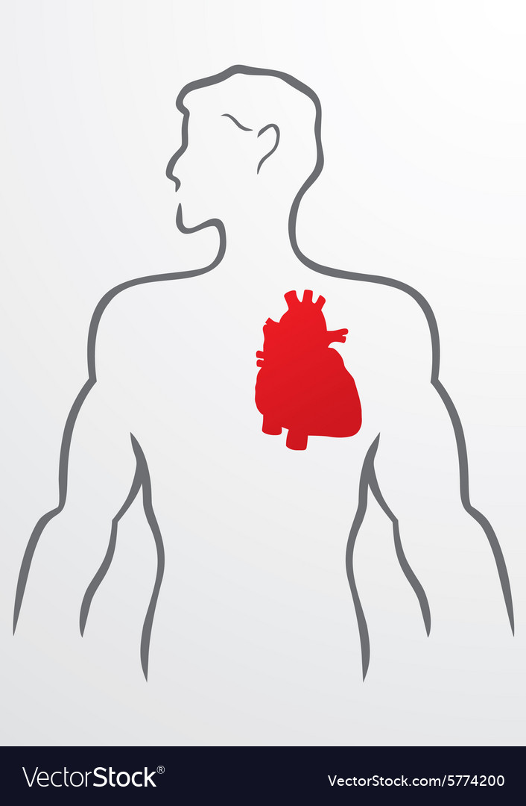

As human beings and UK citizens you have certain rights which fall under the A Human Rights Act 1998.
As a group, and with your tutor, discuss the rights listed below. As you work down the list, tick the ones you appreciate:
the right to life ( ) the right to a fair trial ( )
the right to privacy ( ) the right to vote ( )
freedom of expression ( ) freedom of religion or conscience ( )
freedom of assembly ( ) Freedom of movement ( )
freedom from torture, inhuman or degrading treatment and slavery ( )

You have some other rights that are a little more specific than those already mentioned, but also covered by law:

The right to remain silent ( ) consumer rights ( )
Parental rights ( ) cultural rights ( )

Choose 2 of the rights you have ticked and describe the impact this right has on your life, or may have in future, or what life may be like without this right:

- ……………………………………………………………
…………………………………………………………………………………………………………………………………………………………………………………………………………………………………………………………………………………………………………………………………………………………………………………………………………………………………………………………………………………………………………….

- ……………………………………………………………
……………………………………………………………………………………………………………………………………………………………………………………………………………………………………………………………………………………………………………………………………………………………………………………………………………………………………………………………………………………………………………

ACTIVITY – On separate paper

Think about the right to vote.
Draw a line down the middle of your page, or fold it in half to make a line.
On one side of the line, do a drawing, a poster or leaflet about what life is like with the right to vote.
On the other side, do a drawing, a poster or a leaflet about what life would be like WITHOUT the right to vote.
Think about Prime Ministers, dictators, laws, policies and things you can VOTE for!
Wherever there are rights, there are responsibilities… B
For instance, it is YOUR responsibility to abide by the law, if you don’t, your right to freedom of movement may be withdrawn by putting you in prison.
Everybody has responsibilities, can you name some for the people in the table below?
Person | Responsibilities
Parent

Bus Driver

Teenager

Nurse/Doctor

Now discuss what would happen if each person neglected their responsibilities and make notes below, think about who would be impacted:
Parent: ………………………………………………………………………………………… ……………………………………………………………………………………………………………………………………………………………………………………………………..
Bus Driver: ……………………………………………………………………………………. ……………………………………………………………………………………………………………………………………………………………………………………………………
Teenager: …………………………………………………………………………………….. ……………………………………………………………………………………………………………………………………………………………………………………………………..
Nurse/Doctor: ………………………………………………………………………………… ……………………………………………………………………………………………………………………………………………………………………………………………………..
What are you responsible for? And what is the impact of neglect your responsibility?
- ………………………………………………………………
……………………………………………………………………………………………………………………………………………………………………………………………………
- ……………………………………………………………….
…………………………………………………………………………………………………………………………………………………………………………………………………….

Personal Growth and Wellbeing

KS4

KS4PGW008

Becoming More Environmentally Aware
RSE & PSHE

Learner Name:
Date Started:
Date Completed:
Tutor Name:
Tutor Feedback:
……………………………………………………………………………………………………………………………………………………………………………………………………………………………………………………………………………………………………………………………………………………………………………………………………………………………………………………………………………………………………………………………………………………………………………………………………………………
Your generation faces risks far beyond our physical environment.
At one time, children may be approached by a ‘man in a white van’, and it was quite simple to explain these dangers.
For your generation, the signs may not be so straight forward.
Why is this? (you have already covered this)
…………………………………………………………………………………………………
Sometimes, online, you may be exposed to material may be damaging to yourself or others.
You have already discussed sending nudes and/or images of children. But what about indecent images of adults as you get older?
If you are over 18, and are in a relationship with somebody over 18, what do you do if they send you images of this nature?
…………………………………………………………………………………………………
What would you expect them to do with images you may have sent them?
…………………………………………………………………………………………………
What may happen if these images are shared outside of the couple?
………………………………………………………………………………………………….
If you are concerned that somebody in an image or video you receive looks young, you should report it to …………………………………………. .
Some content online is harmful and may pose a risk to people who view it.
What are the risks of viewing such material?
…………………………………………………………………………………………………………………………………………………………………………………………………….
If somebody sends you an image, does this mean they consent to you showing other people?
…………………………………………………………………………………………………..
If somebody sends you an image, does this mean they consent to sex or sexual activity with you?
…………………………………………………………………………………………………..
Does somebody consent to sex or sexual activity by holding hands or kissing?
…………………………………………………………………………………………………
What are the best ways to ensure somebody does consent to sex/sexual activity?
…………………………………………………………………………………………………………………………………………………………………………………………………….
The online environment is essential for your generation but it is also important to be engaged in the physical world.
What are some similarities between the online world and the physical world?
………………………………………………………………………………………………………………………………………………………………………………………………………………………………………………………………………………………………………
What about the differences?
………………………………………………………………………………………………………………………………………………………………………………………………………………………………………………………………………………………………………..
What tends to happen when people see other peoples ‘amazing lives’ on social media?
……………………………………………………………………………………………………………………………………………………………………………………………………..
What about comparing physical appearances? Are people’s appearances online always real?
…………………………………………………………………………………………………………………………………………………………………………………………………….
How would you identify harmful behaviours online, such as:
Bullying:………………………………………………………………………………………..
Abuse:………………………………………………………………………………………….
Harassment:…………………………………………………………………………………...
How can you report these behaviours?
…………………………………………………………………………………………………………………………………………………………………………………………………….
If you would like support for the issues raised you could speak to a tutor, mentor or Kellie at school or:
Report it to Police at: https://www.ceop.police.uk/Safety-Centre/
Get support from NSPCC on: 0808 800 5000

ACTIVITY – On separate paper
Make a poster or leaflet explaining either: (Choose one)
- That people online may not be who they claim to be
- That people online may be exaggerating lifestyle or photoshopping images
- Trying to scam you
Now that you have a good understanding of your global/online environment, it’s time to look at your physical environment.
The way we live causes issues all over the planet. Can you name and describe 3? A
1)………………………………………………………………
………………………………………………………………………………………………………………………………………………………………………………………………………………………………………………………………………………………………………
2)………………………………………………………………
………………………………………………………………………………………………………………………………………………………………………………………………………………………………………………………………………………………………………23)………………………………………………………………
………………………………………………………………………………………………………………………………………………………………………………………………………………………………………………………………………………………………………
ACTIVITY - B
In your group, choose 1 environmental issue and produce a campaign to correct it.
You may want to make:
- A mission statement, explaining why change needs to take place
- Informative posters, pointing out what people can do to help
- A presentation for schools, explaining the importance of the next generations actions
- ‘Job descriptions’ for each group member

