English

KS4

Units Covered:
KS3E001 – Basic Skills
Vocabulary P1
Grammar; Commas, Apostrophes, Characters P2
Complex Sentences P3
Paragraphs P4
KS3E002 – Writing & Text
Understanding Text & Comprehension P1
Writing for Purpose P2
Vocabulary Booster P3
Range of Text (arguments/complaints & Letters) P4
Imaginative Writing (stories, Poems, Scripts) P5
KS3E003 – Language
Difference Between Written & Spoken English P1
1st & 3rd Person P2

English

KS4E001

Learner Name:
Date Started:
Date Completed:

Tutor Name:
Tutor Feedback:
……………………………………………………………………………………………………………………………………………………………………………………………………………………………………………………………………………………………………………………………………………………………………………………………………………………………………………………………………………………………………………………………………………………………………………………………………………………

Give some options for words we can use INSTEAD of the keywords below:
Keyword | Alternatives (At least 3)
Friend
Happy
Hot
Cold

List words that describe these images:
……………………………………………………………………………………………………………………………………………………………………………………………………………………………………………………………………………………
……………………………………………………………………………………………………………………………………………………………………………………………………………………………………………………………………………………

……………………………………………………………………………………………………………………………………………………………………………………………………………………………………………………………………………………
……………………………………………………………………………………………………………………………………………………………………………………………………………………………………………………………………………………

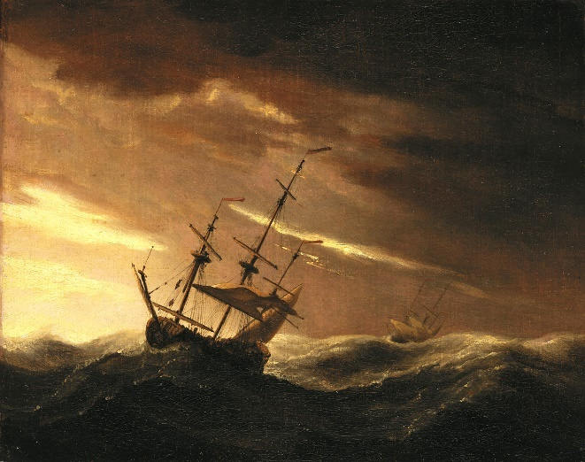
……………………………………………………………………………………………………………………………………………………………………………………………………………………………………………………………………………………
……………………………………………………………………………………………………………………………………………………………………………………………………………………………………………………………………………………

The apostrophe has three uses:
1) to form possessive nouns, i.e. Bobby’s Ferrari – The Ferrari belongs to Bobby
2) to show the omission of letters, i.e. It’s freezing – IT IS freezing
3) to indicate plurals of letters, numbers, and symbols i.e. Meg got A’s in her exams
Write a sentence using apostrophes for ownership/possessive nouns:
……..…………………………………………………………………………………………..
Write a sentence using apostrophes to show the omission of letters:
……..…………………………………………………………………………………………..
Write a sentence using apostrophes to show plurals of letters or numbers:
…………………………………………………………………………………………………..
Commas are used to indicate a smaller break than a ‘Full-Stop’.
We use commas to separate subjects or clauses (parts) of compound sentences.
Bobby drove the red Ferrari , so he left his Porsche at home.
The Ferrari and the Porsche are separate subjects. Now write a sentence yourself:
…………………………………………….. , ……………………………………………..
We use some other ‘special characters’ when writing, can you name them?
? ………………………………………..
! .……………………………………….
Now write a sentence containing ‘?’
…………………………………………………………………………………………………..
Now write a sentence containing ‘!’
…………………………………………………………………………………………………..
Now write a sentence with dialogue that contain ‘?’ or ‘!’
…………………………………………………………………………………………………..
Complex Sentences are used to give more information or to explain the sentences main point and are made up of two parts; the independent clause and the dependent clause.
For example:
You will definitely lose, if you don’t try.

Independent clause Subordinating conjunction Dependent clause
In this sentence, ‘if’ is the subordinating conjunction. It links a statement to a reason.
I don’t know the way, because I have never been before.

Independent clause Subordinating conjunction Dependent clause
In this sentence ‘because’ is the word that links the reason to the statement.
List some words that can be used as subordinating conjunctions:
………………………… ………………………………. …………………………..
………………………… ………………………………. …………………………..
Now try writing some COMPLEX sentences yourself:
Independent Clause Subordinating Conjunction Dependent Clause

…………………………………. ……………………….. …………………………………
…………………………………. ……………………….. …………………………………
…………………………………. ……………………….. …………………………………
…………………………………. ……………………….. …………………………………
…………………………………. ……………………….. …………………………………
…………………………………. ……………………….. …………………………………
…………………………………. ……………………….. …………………………………
Paragraphs are medium-sized units of writing, longer than sentences, but shorter than sections, chapters, or entire works.
They connect the “small” ideas of individual sentences to a “bigger” idea.
Link some sentences together to make a paragraph:
……………………………………………………………………………………………………………………………………………………………………………………………………………………………………………………………………………………………………………………………………………………………………………………………………………………………………………………………………………………………………………..
When writing in paragraphs, you can leave a space at the start of a new paragraph (write the first word about an inch from the start of the line) or leave a line gap between paragraphs.
We change paragraph when we start writing about a different topic:
Bobby was driving very fast on his way to the shop. He was quite dangerous when he came to traffic lights and pedestrian crossings. Mary said “I don’t know how we arrived in one piece!” She must have been so frightened.
Once they got to the shop Bobby carried the broken toaster to the Customer Service Desk and asked for a refund. The toaster was only two days old and was not working.
In the first Paragraph the topic is the journey to the shop.
In the second paragraph the topic is the faulty toaster.
Now you try:
…………………………………………………………………………………………………………………………………………………………………………………………………………………………………………………………………………………………………………………………………………………………………………………………………………………………………………………………………………………………………………………………………………………………………………………………………………………………………………………………………………………………………………………

