KS4 Initial Assessments

Reading Score:

Put correct grammar in the following sentences:
Bobbys pen was on the floor

Megan and Hugo went to the park even though it was raining to play with the dogs ball.

Sarah said do you want anything from the shop as she walked out the door and nobody replied.
Tell us about who you live with and where you live:
……………………………………………………………………………………………………………………………………………………………………………………………………………………………………………………………………………………………………………………………………………………………………………………………………………………………………………………………………………………………………………
Can you think of any words that rhyme with;
Stage ……………………………………………………………………….
Kite ……………………………………………………………………….
Feet ………………………………………………………………………..
Now …………………………………………………………………………

Put the correct maths symbols in the following sums:
4 12 = 16 8 8 = 16 11 4 = 7 19 3 = 16

5 3 = 16 16 2 = 8 8 2 = 16 20 4 = 5

How many corners do the following chapes have:
Square ……………
Circle ……………
Triangle …………..
Hexagon ………….

What is the area and perimeter of the square:

Area …………………
5cm Perimeter ………………….

How many Centimetres wide is your page? (use a ruler)

…………………cm

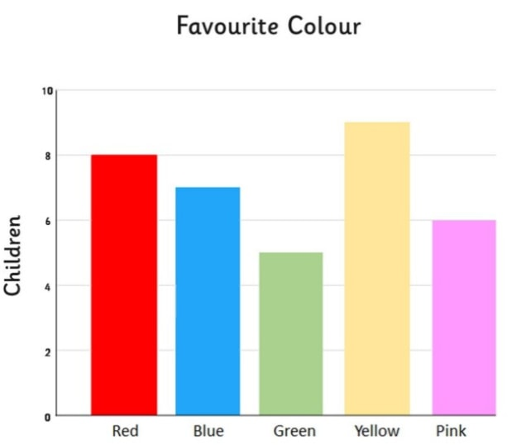
Look at the graph below:

How many children like pink? …………………..
Which colour is least favourite? ………………..
How many children like blue? ………………….

