English

KS3

Units Covered:
KS3E001 – Basic Skills
Vocabulary P1
Word Types P2
Forming Sentences P3
Grammar: Commas P4
Grammar: Dialogue & Special Characters P5
Grammar: Apostrophes P6
KS3E002 – Writing & Text
Writing in Paragraphs P1
Writing for Purpose P2
Writing Notes/Scripts P3
Imaginative Writing P4
Fact & Fiction P5
Range of Text P6
Vocabulary P7
KS3E003 – Language
Difference Between Written & Spoken English P1
Effective Grammar P2

English

KS3E001

Learner Name:
Date Started:
Date Completed:

Tutor Name:
Tutor Feedback:
……………………………………………………………………………………………………………………………………………………………………………………………………………………………………………………………………………………………………………………………………………………………………………………………………………………………………………………………………………………………………………………………………………………………………………………………………………………

What does the word ‘vocabulary’ mean?
……………………………………………………………………………………………………………………………………………………………………………………………………
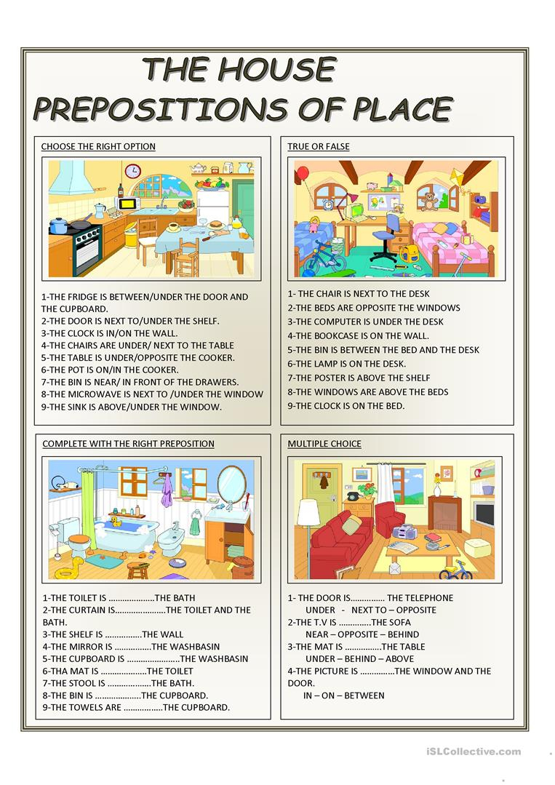
Give some options for words we can use INSTEAD of the keywords below:
Keyword | Alternatives (At least 3)
Good
Bad
Big
Small

VERBS:
A verb is a word that indicates a physical action, such as:
Play, Ride, Hit, Walk, Climb, …………………………. , ………………………… .
NOUNS:
A noun is a word that refers to a thing, Such as:
Door, Table, Book, Pen, Car, …………………………... , …………………………. .
Nouns are also names, such as; Bobby, Ferrari, Iphone, ……………………..
PRONOUNS:
We use pronouns instead of nouns when talking about something or someone that has already been named, such as:
He, She, They, Them, It, We or I.
ADJECTIVES:
Adjectives are used to describe nouns, such as:
Solid, Long, Thick, Blue, Red, ………………………….. , ……………………………
Draw a line from the word types, to their examples in the sentence below:
NOUN VERB PRONOUN ADJECTIVE

Bobby said he drove the red Ferrari.
Complete the table below with your own examples:
NOUNS | PRONOUNS | ADJECTIVES | VERBS

A SIMPLE sentence follows Subject + Verb + Object word order.
She (subject) finished (verb) her work (object).
He (subject) washed (verb) his car (object).
Now try and make a simple sentence yourself:
…………………………………………………………………………………………………..
A COMPOUND sentence is made up of two independent clauses joined by a coordinating conjunction (for, and, nor, but, or, yet, or so) and a comma or by a semicolon alone.
Example: The pirate captain lost her treasure map, but she still found the buried treasure.
Now turn the SIMPLE sentences above into compound sentences. (There is space)
Write three compound sentences below using the given objects:
1) A Football
……………………………………………………………………………………………………………………………………………………………………………………………………
2) A Tree
…………………………………………………………………………………………………………………………………………………………………………………………………….
3) A Train
……………………………………………………………………………………………………………………………………………………………………………………………………
Add to these SIMPLE sentences to create COMPOUND sentences:
Use Conjunctions (for, but, and, so, or, yet, nor)
My favourite food is Pasta…………………………………………………………………...
Trent likes to play Football…………………………………………………………………..
The movie was funny…………………………………………………………………………
Commas are used to indicate a smaller break than a ‘Full-Stop’.
We use commas to separate subjects or clauses (parts) of compound sentences.
Bobby drove the red Ferrari , so he left his Porsche at home.
The Ferrari and the Porsche are separate subjects.
Trent likes to play Football , but he plays Rugby at School.
Football and Rugby are separate subjects. Now write two sentences for yourself:
…………………………………………….. , ……………………………………………..
…………………………………………….. , ……………………………………………..
We also use commas to separate items in a list or series, such as;
I went to the shop for bread, milk, eggs and kitchen roll.
Or;
Bobby’s Ferrari was loud, fast, red and very clean.
Now try writing a sentence with a list:
…………………………………………………………………………………………………
Now try writing a sentence with a series of adjectives:
………………………………………………………………………………………………….
Put a comma in the correct place in the sentences below:
- I went to the park with George Sarah Hugo Lilly and Levi.
- On Saturday I went to the chippy the match the garden centre and then home.
- My dad painted the fence the shed and then he washed the car.
- For Christmas she wanted a doll a laptop a hairdryer and a pair of boots.
- We got sausage bacon eggs ham and chicken from the market.
- He hoovered the hallway the living room the stairs and the landing.
- Shall we go for a coffee cake and a walk?
- Do you want ham egg and chips or sausage gravy and mash?
- I saw Paul Ben David Gary and Charlie on the bus.
- We have got juice lemonade tea coffee or water.
Dialogue means we are writing about somebody who is talking.
We show this by using ‘speech marks’ - “ ”
The speech marks go either side of what is actually being said, for example:
Michael shouted “help, I can’t swim!”
Try putting the speech marks into the sentences below:
- Sarah asked can I have some more sugar, please?
- Hugo screamed GET IN when Nunez scored.
- Grandad said pass me the newspaper.
Now write your own sentences with dialogue:
- …………………………………………………………………………………………..
- …………………………………………………………………………………………..
- …………………………………………………………………………………………..
We use some other ‘special characters’ when writing, can you name them?
? ………………………………………..
! .……………………………………….
Now write some sentences containing ‘?’
- …………………………………………………………………………………………..
- …………………………………………………………………………………………..
- …………………………………………………………………………………………..
Now write some sentences containing ‘!’
- …………………………………………………………………………………………..
- …………………………………………………………………………………………..
- …………………………………………………………………………………………..
Now write some sentences with dialogue that contain ‘?’ or ‘!’
- …………………………………………………………………………………………..
- …………………………………………………………………………………………..
- …………………………………………………………………………………………..
The apostrophe has three uses:
1) to form possessive nouns, i.e. Bobby’s Ferrari – The Ferrari belongs to Bobby
2) to show the omission of letters, i.e. It’s freezing – IT IS freezing
3) to indicate plurals of letters, numbers, and symbols i.e. Meg got A’s in her exams
Write three sentences using apostrophes for ownership/possessive nouns:
- …………………………………………………………………………………………..
- …………………………………………………………………………………………..
- …………………………………………………………………………………………..
Write three sentences using apostrophes to show the omission of letters:
- …………………………………………………………………………………………..
- …………………………………………………………………………………………..
- …………………………………………………………………………………………..
Write three sentences using apostrophes to show plurals of letters or numbers:
- …………………………………………………………………………………………..
- …………………………………………………………………………………………..
- …………………………………………………………………………………………..
How many words can you think of that can be shortened with an apostrophe?
……………………………………… ………………………………………
……………………………………… ………………………………………
……………………………………… ………………………………………
……………………………………… ………………………………………
Put apostrophes where they could be in these sentences:
- We went to School in Alexs car.
- We got a taxi because its raining.
- I love watching Salah, dont you?
- I wouldnt do that If I was you.
- I couldnt do the jungle challenges.

