Religious Studies

KS3/4RS001

An Insight to Christianity

Learner Name:
Date Started:
Date Completed:

Tutor Name:
Tutor Feedback:
……………………………………………………………………………………………………………………………………………………………………………………………………………………………………………………………………………………………………………………………………………………………………………………………………………………………………………………………………………………………………………………………………………………………………………………………………………………
On your own,
Can you describe who you think God is?
……………………………………………………………………………………………………………………………………………………………………………………………………………………………………………………………………………………………………….
After you have discussed your thoughts with your tutor and the group, is there anything else you can think of?
……………………………………………………………………………………………………………………………………………………………………………………………………………………………………………………………………………………………………….
Can you think of any reasons people may pray to god?
………………………………………………………………………………………………………………………………………………………………………………………………………………………………………………………………………………………………………..
What do Christians believe about God?
……………………………………………………………………………………………………………………………………………………………………………………………………………………………………………………………………………………………………….
Who is God in terms of the Holy Family?
……………………………………………………………………………………………………………………………………………………………………………………………………

ACTIVITY – On separate paper
Write the ‘Our Father’ prayer:
Make sure you:
- Decorate the page (think about clouds, rainbows, The Cross, rays of light)
- Write as neatly as possible, this may go on the wall!
In Terms of the Holy Family, who is Jesus?
…………………………………………………………………………………………………………………………………………………………………………………………………….
Describe was Jesus Born? Think about the location, not just the Town/City:
……………………………………………………………………………………………………………………………………………………………………………………………………..
Who game to visit Jesus after he was born, and what gifts did they bring?
……………………………………………………………………………………………………………………………………………………………………………………………………
Can you think of anything the Bible says Jesus did, or places he went?
1) ……………………………………………………………………………………………….
2) ……………………………………………………………………………………………….
3) ……………………………………………………………………………………………….
How did Jesus die?
…………………………………………………………………………………………………………………………………………………………………………………………………….
Who persecuted Jesus and the Disciples?
…………………………………………………………………………………………………
In the Bible, Jesus says ‘God is faithful; He will not tempt you beyond what you can bear!’
Temptations now are very different to temptations 2000 years ago, what might you class as a temptation in your life?
……………………………………………………………………………………………………………………………………………………………………………………………………
ACTIVITY - On separate paper
Write the bible quote above and decorate the page with the temptations you have listed.
Who were Mary and Joseph?
……………………………………………………………………………………………………………………………………………………………………………………………………
What was special about Mary’s conception?
…………………………………………………………………………………………………………………………………………………………………………………………………….
What was Joseph’s job?
……………………………………………………………………………………………………………………………………………………………………………………………………..
As a group, discuss whether you think Mary and Joseph were rich or poor, make notes for each argument below:
Arguments for Rich | Arguments for Poor

ACTIVITY – On separate paper
Draw the scene where Jesus was born.
Make sure you:
- Think about life 2000 years ago (did they have electricity)

Our lives operate around the Christian Calendar, list some important days we celebrate due to Christianity:
………………………………………. …………………………………….
………………………………………. ……………………………………..
Why is Christmas important to Christians?
……………………………………………………………………………………………………………………………………………………………………………………………………..
Why is Easter important to Christians?
…………………………………………………………………………………………………………………………………………………………………………………………………….
Why do Christians eat pancakes on Shrove Tuesday?
……………………………………………………………………………………………………………………………………………………………………………………………………
What is Lent, and why is it followed?
…………………………………………………………………………………………………………………………………………………………………………………………………….
What happens on Ash Wednesday?
…………………………………………………………………………………………………………………………………………………………………………………………………….
What is advent, and how do we mark it?
…………………………………………………………………………………………………………………………………………………………………………………………………….

ACTIVITY – On Separate paper/card

Make a Christmas Car for a friend, relative or Tutor

Religious Studies

KS3

KS3/4RS002

An Insight to Judaism

Learner Name:
Date Started:
Date Completed:

Tutor Name:
Tutor Feedback:
……………………………………………………………………………………………………………………………………………………………………………………………………………………………………………………………………………………………………………………………………………………………………………………………………………………………………………………………………………………………………………………………………………………………………………………………………………………
Jews originated in the ……………………… Millennium and the Middle East.
At the time the area was called the Levant, and the country was known as …………..
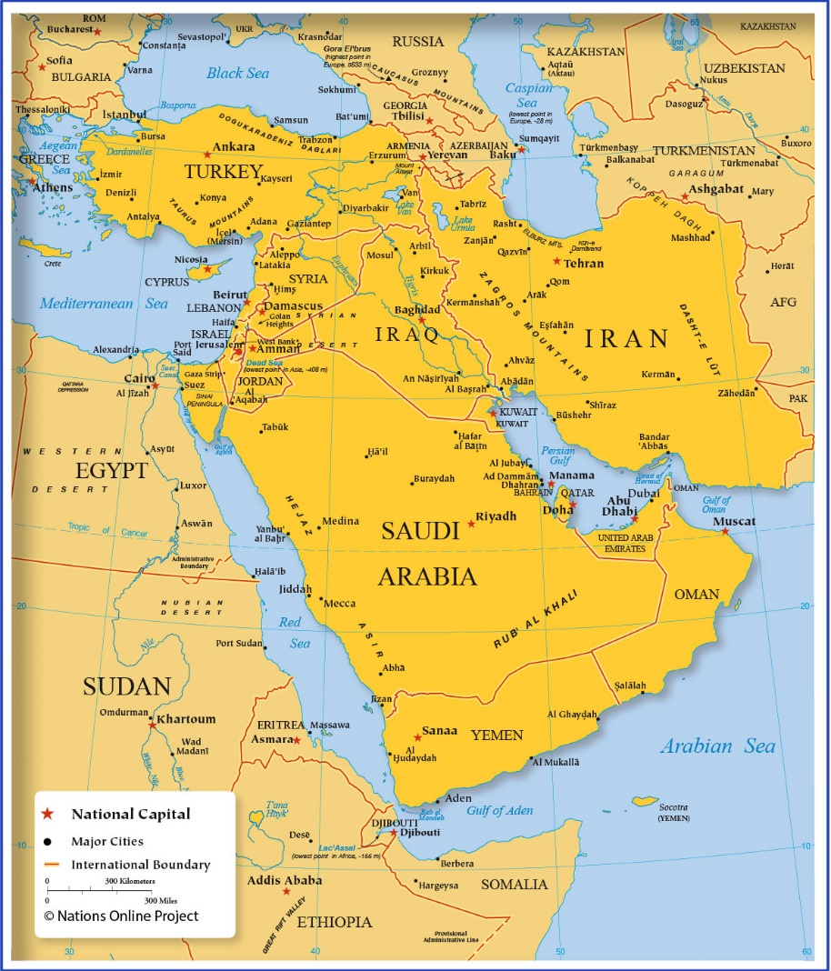
Can you find and circle the area on this map?

A long time ago, The ……………………… believed they were entitled to govern the area of ………………………. and destroyed the Jews Second Temple.
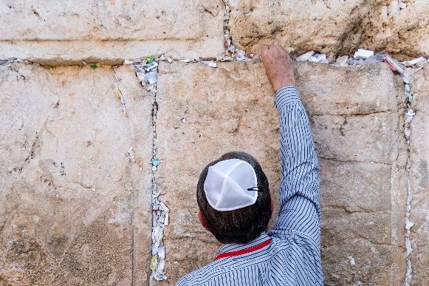
The …………………. Wall of the Second Temple is all that remains, and Jews take pilgrimages to Pray at the wall by writing their …………….. on paper and putting it in the gaps in the stones.

ACTIVITY – On separate paper
- Write a prayer that you could leave
- Think about family or hopes & dreams

Jews believe that there is ……….. God, who has made a covenant with the Jewish people.
They believe that God communicates with believers through ……………… and that he ……………………… bad behaviour and ……………………. good.
On a Saturday, jews celebrate ……………………. or the ……………………. This means that Jews will ……………. and take time away from their daily labours or work.
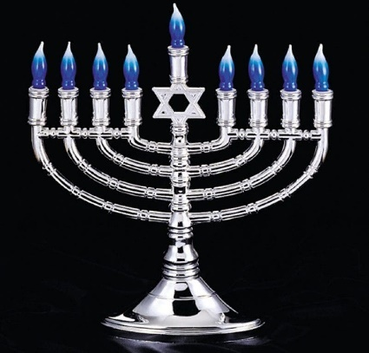
Jews also celebrate their dedication to the religion with …………………….. and they use this time to light special ………………………..

There are 8 candles on a Menorah and they are lit one per night for 8 nights to celebrate a time when Jews reclaimed the Second Temple. Before reclaiming the Second Temple Jews were …………………. And signs of their religion were concealed, so the Menorah represents ……………………….. to express themselves.
When Jewish Children reach 12 or 13 they celebrate a ……………………………..
This is when jews see the children as becoming an …………………..
After this, they are …………………………… for their own actions and take responsibility for their own ……………………………..
Jews use the ……………. Of ………………. As a symbol. David was the ……………….. King of Israel.
You may know David as the young Shepherd who slayed ……………………….

Religious Studies

KS3

KS3/4RS003

An Insight to Hinduism

Learner Name:
Date Started:
Date Completed:

Tutor Name:
Tutor Feedback:
……………………………………………………………………………………………………………………………………………………………………………………………………………………………………………………………………………………………………………………………………………………………………………………………………………………………………………………………………………………………………………………………………………………………………………………………………………………
Hinduism is the World’s …………………….. religion and has ……………………… followers. The religion is ………………… years old, that’s …………….. as old as Christianity!
……. % of the World’s Hindus live in ………………….
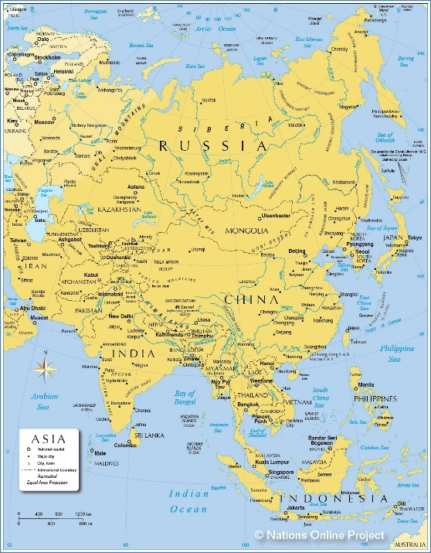
Can you point India our on this map of Asia?

The …………………….. Empire controlled India from 1757 until 1947. At first, Hinduism was allowed but towards the end of the Empire Control they tried to force Hindus to follow ………………………………………….
Hindus have many ……………

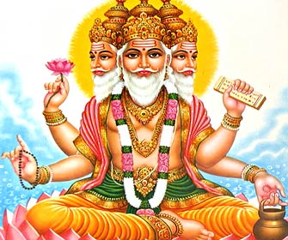
Brahma, is believed to have created the …………… and all …………….. things.
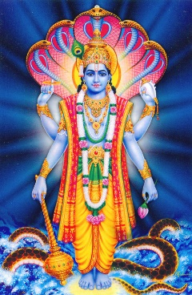

Vishnu, is believed to
protect the ………………………….

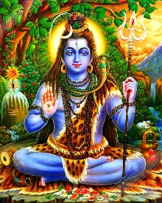
Shiva, is believed to ………………… the universe in order to recreate it.

Hindu’s have a lot of ……………………………………..
One of the most common is ………………………………… as it can be carried out …………………………. . Some people do ………………………. Techniques, some may do repetitive …………………………….
Hindus often practice Satsang, which is a …………………… meet, or a group of people meditating together.
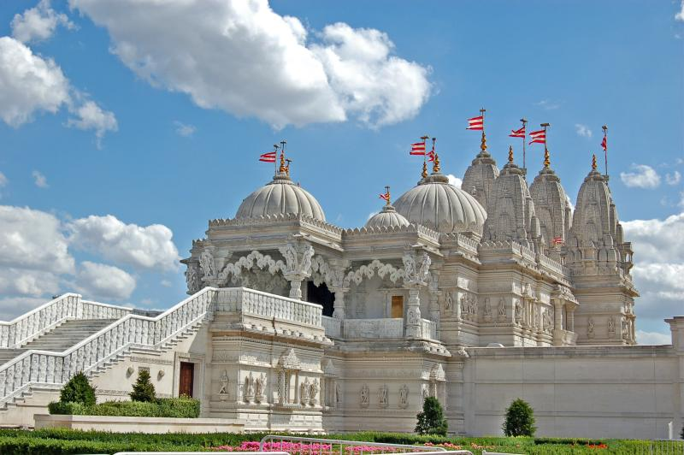
Hindu temples are also very ornate and look like palaces.

Durga Puja is a Hindu festival in October. Hindus spend around a week …………………… and celebrating the goddess, Durga. This is celebrated with dances, drama and songs. People dress up in traditional clothing and share food with neighbours and relative who travel to be together.
Hindus try to live by the rules of Ahimsa, which means not to harm any living thing.
For this reason, many Hindus eat ………………………………….. diets.
Hindus also worship ………… as they are linked to some gods in the form of bulls.
In India, cows roam the streets freely and are unchallenged, …………… will stop in the road and ……………………………… will stand on the pavement until a cow passes by so as not to disturb the cow going about it’s business.

ACTIVITY – Using a search engine: Name some famous Hindus
…………………………………………… …………………………………………...
…………………………………………… …………………………………………...
…………………………………………… …………………………………………...

Religious Studies

KS3/4RS004

An Insight to Islam

Learner Name:
Date Started:
Date Completed:

Tutor Name:
Tutor Feedback:
……………………………………………………………………………………………………………………………………………………………………………………………………………………………………………………………………………………………………………………………………………………………………………………………………………………………………………………………………………………………………………………………………………………………………………………………………………………

Islam is the …………………….. of the worlds main religions, believed to have created between the year 600 and 700.
The word Islam means ‘submission to the will of ……. ‘ or, ‘whatever god wants’.
Muslims refer to their holy book as the ………………… and they worship in buildings called ………………………….
Muslims believe that there will be a day of …………………………… and that there is ……………. after death.
Muslims live according to the ……………… pillars of Islam:
- Profession of faith. Accepting that there is one god and Muhammad is the prophet.
- Prayer. Muslims pray 5 timers per day facing ………………..
- Alms. This is donating a portion of your income to the …………………………..
- Fasting. This is not eating or drinking during ………………………
- Pilgrimage. Muslims who are well enough and can afford to visit ………… do

When praying, Muslims roll out a prayer mate and face towards Mecca, to us, this is the east.

ACTIVITY – On separate paper
Use a full sheet of paper as a template for a prayer mat.
- Draw some patterns
- Choose your colours
- Maybe cut the top and bottom like the examples below?
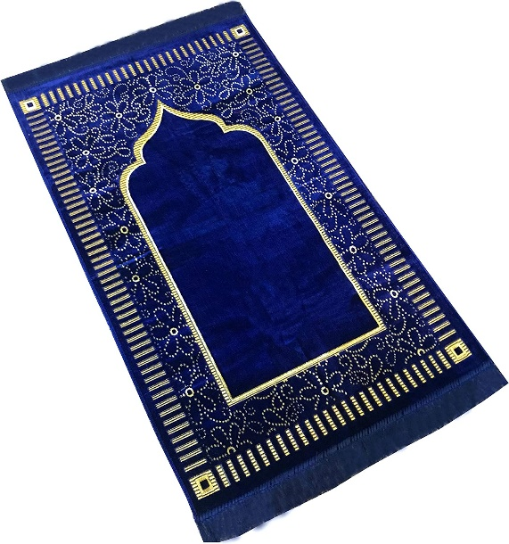
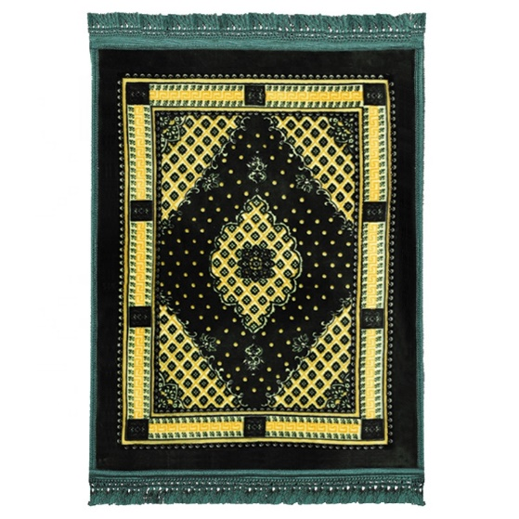
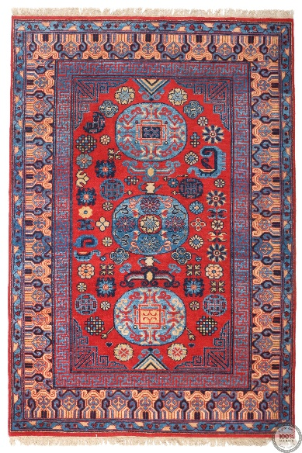

Muslims take part in a month long fast known as ……………………….
Completing Ramadan is seen as a challenge that strengthens ……………………… relationship with God by showing ……………………………….
When the ……….. sets of an evening, Muslims can eat and drink, when the sun comes back up, fasting begins again.
At the end of Ramadan there is a festival called ………
This is when Ibrahim ……………………. Ismail to show obedience to God.
During Eid, lots of families and neighbours gather together, they will ……………. To symbolise the end of Ramadan and will usually share a big meal, or a ………………..
Some Muslim women choose to wear a ……………….. or a ………………….. , this is basically a veil to cover their hair, head and sometimes ………………
Muslim women wear Hijabs because they want to remain modest, not showing off their clothes, beauty or jewellery.
Others wear the head covering as a statement of ………………………. towards western culture.
Unfortunately, there are some countries where women are …………………. to wear Burkas for religious/legal reasons and punishments can be quite ……………………..

ACTIVITY –
During Eid, many Muslims put lights in their windows and decorate their homes or temples with lanterns.
Fold a separate piece of paper in half (top to bottom) and decorate it with colours and patterns.
Cut the paper at 1inch (roughly) intervals leaving around 2 inches either side.
Roll the paper so you can glue the top and the bottom together.
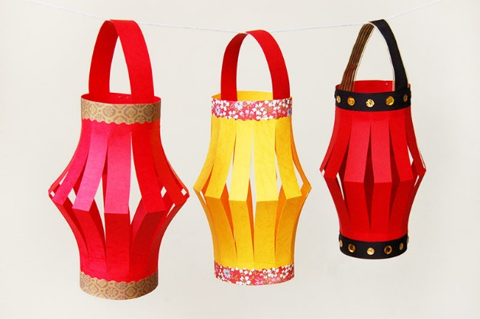
Cut a 1inch slice of paper and glue it either side of the top of your lantern like a handle.
