Geography

KS3/4G001

Local Landmarks

Learner Name:
Date Started:
Date Completed:

Tutor Name:
Tutor Feedback:
……………………………………………………………………………………………………………………………………………………………………………………………………………………………………………………………………………………………………………………………………………………………………………………………………………………………………………………………………………………………………………………………………………………………………………………………………………………
What is a Landmark?
……………………………………………………………………………………………………………………………………………………………………………………………………
If you wonder around Liverpool City Centre, what landmarks stand out?
…………………………………………………………………………………………………………………………………………………………………………………………………….
The tallest building in Liverpool is Beetham Plaza/West Tower(140m), but the second tallest is better known. It is 138m, very skinny, and has something that looks like a UFO at the top. Do you know what it is?
…………………………………………………………………………………………………..
Not all landmarks are manmade. Can you think of any other types of landmarks?
…………………………………………………………………………………………………..
Landmarks are useful when giving directions, list some landmarks you may use to direct somebody to School:
…………………………………………… …………………………………………..
…………………………………………… …………………………………………..

Give directions, using landmarks, from the Rhys Jones Centre to the main gate/carpark entrance of Croxteth Park: (your tutor will help you)
- Leave RJCC through the ……………………………………..
- …………………………………………………………………………………………
- …………………………………………………………………………………………
- …………………………………………………………………………………………
- …………………………………………………………………………………………
- …………………………………………………………………………………………
- …………………………………………………………………………………………
- …………………………………………………………………………………………
- …………………………………………………………………………………………

If you wanted to see local landmarks, where would you go to see:
St. Johns Beacon?.........................................................................................................
Crosby Lifeboat House?................................................................................................
Everton Valley?..............................................................................................................
Parbold Hill?..................................................................................................................
Can you think of any other points of reference either in the city or near where you live?
…………………………………………… …………………………………………..
…………………………………………… …………………………………………..
On your own, or in small groups,
Try and name as many of the Landmarks below:
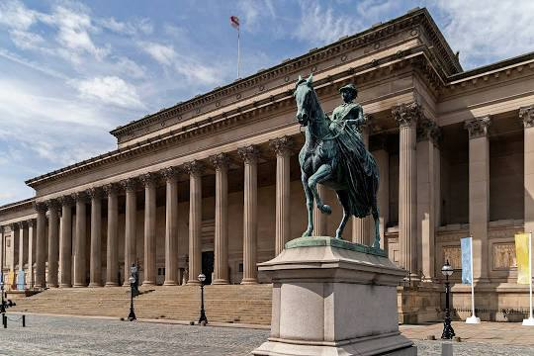
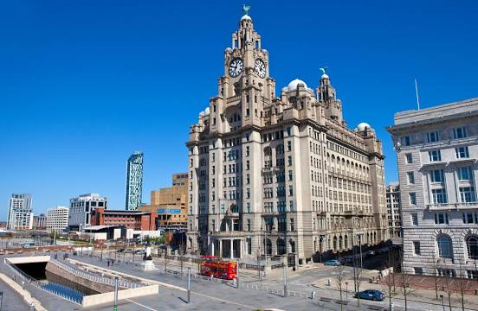
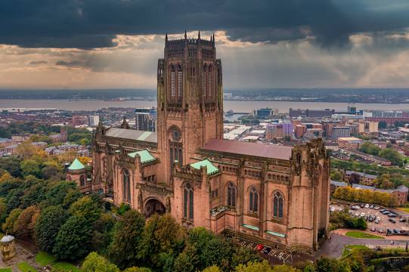
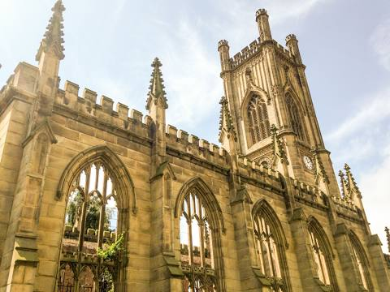
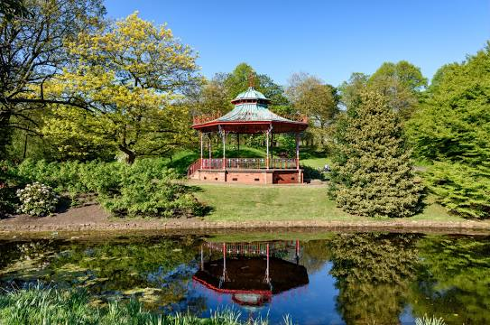
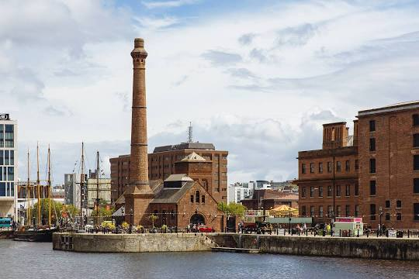
…………………………. …………………………… …………………………..

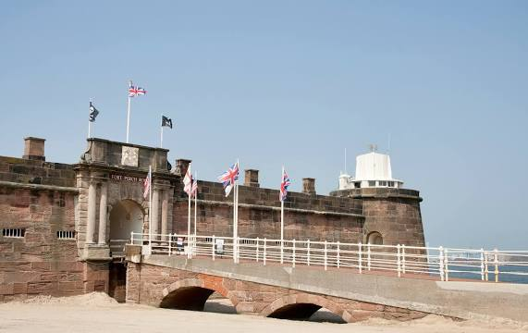
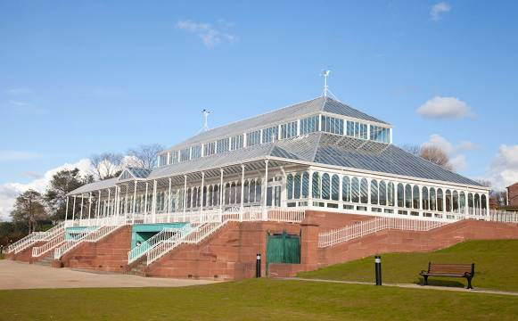
………………………… …………………………… ………………………….
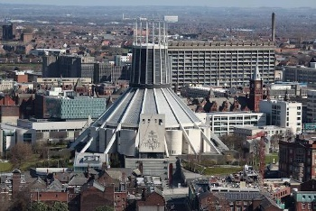

…………………………… …………………………….. …………………………..

Geography

KS3/4G002

Regional Landmarks

Learner Name:
Date Started:
Date Completed:

Tutor Name:
Tutor Feedback:
……………………………………………………………………………………………………………………………………………………………………………………………………………………………………………………………………………………………………………………………………………………………………………………………………………………………………………………………………………………………………………………………………………………………………………………………………………………
If we live in Liverpool, Knowsley, Sefton or the Wirral we are from the ………… ………… of England.
One of the biggest landmarks in the North West is ………………….. Tower.
On a clear day we can see Blackpool Tower if we look down the River ………………
There are lots of towns and cities on the River Mersey;
…………………………………………… …………………………………………..
…………………………………………… …………………………………………..
Liverpool is also the end of the …………………. – Liverpool Canal which is …….. miles long.
Can you name any of the major roads (and Motorways) that link areas of the northwest?
…………………………………………… …………………………………………..
…………………………………………… …………………………………………..
Can you name any airports in the region?
…………………………………………… …………………………………………..
…………………………………………… …………………………………………..
What about major train stations?
…………………………………………… …………………………………………..
…………………………………………… …………………………………………..
Because most a lot of the North West is on the coast, the wear can be exceptionally:
…………………………………………… …………………………………………..
…………………………………………… …………………………………………..
We also have some hilly areas such as:
…………………………………………… …………………………………………..
…………………………………………… …………………………………………..

Because Liverpool is right on the River Mersey we have transport links that other cities do not have. We can get Ferries to:
…………………………………………… …………………………………………..
…………………………………………… …………………………………………..
At the map, can you draw a line for one of the ferry routes you have named?
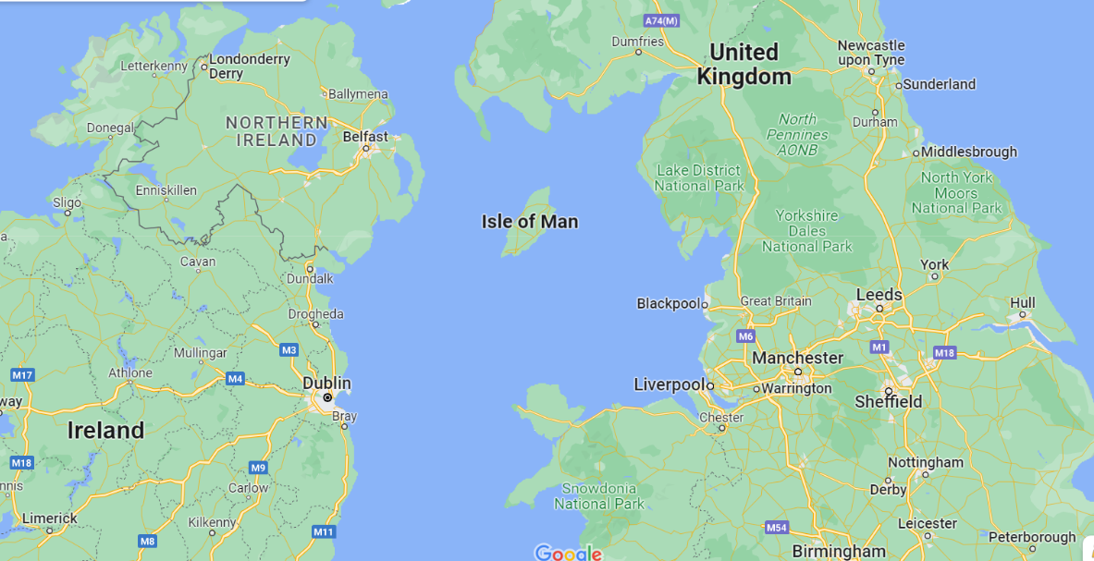
Route:………………………………………………………..

Before industrialisation our area was very ………………………….. . Most of the space was taken up with farmland owned by lords, such as Lord Derby of Croxteth Park.
Can you think of reasons that these Lords’ land has been made smaller?
…………………………………………… …………………………………………..
…………………………………………… …………………………………………..
How has ‘Big Business’ effected our regions geography?
……………………………………………………………………………………………………………………………………………………………………………………………………………………………………………………………………………………………………….
Can you name any big business who have had an impact on our region?
…………………………………………… …………………………………………..
…………………………………………… …………………………………………..
Geography

KS3/4G003

British Geography

Learner Name:
Date Started:
Date Completed:

Tutor Name:
Tutor Feedback:
……………………………………………………………………………………………………………………………………………………………………………………………………………………………………………………………………………………………………………………………………………………………………………………………………………………………………………………………………………………………………………………………………………………………………………………………………………………

Can you name any large British Cities?
…………………………………………… …………………………………………..
…………………………………………… …………………………………………..
The …………………………….. of a city is how many people live there.
Research the population of the cities you have named:
- ………………………………………. - …………………….. people
- ………………………………………. - …………………….. people
- ………………………………………. - …………………….. people
- ………………………………………. - …………………….. people
Name one landmark in each city you have named:
City | Landmark

Label your four cities on the map:
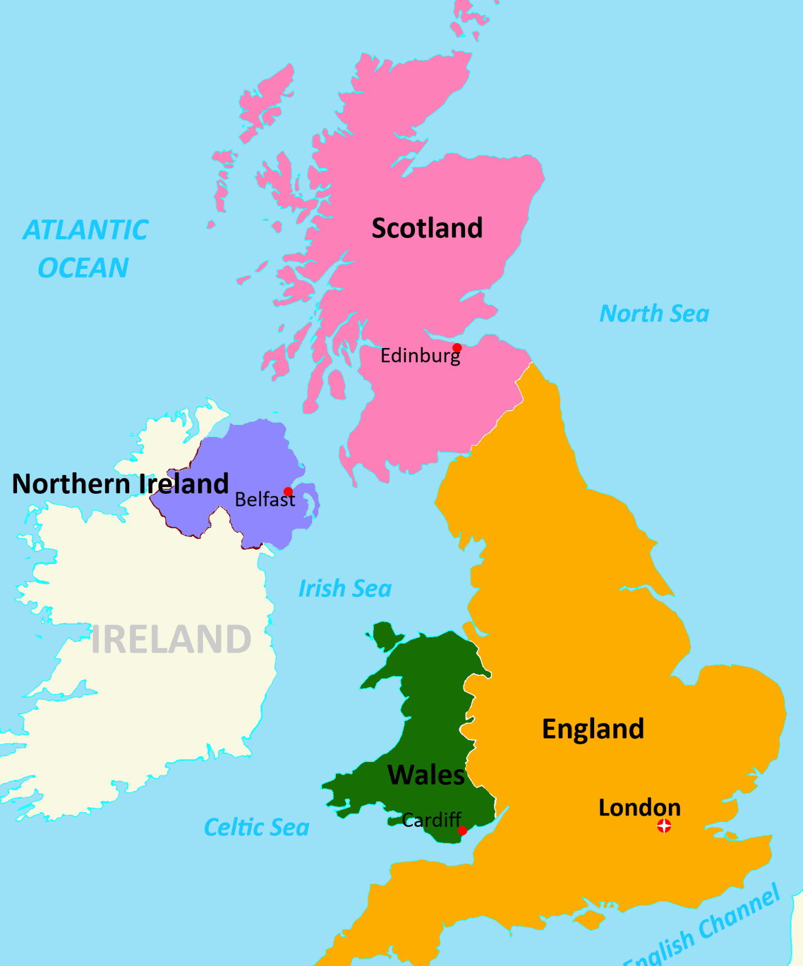

As we have already discussed, Liverpool is on the banks of the River Mersey.

Can you name any more rivers in the UK?
…………………………………………… …………………………………………..
…………………………………………… …………………………………………..

Can you list the towns and cities that are on or near to each river?
River | Nearby Towns and Cities

Can you name any major UK Airports?
…………………………………………… …………………………………………..
…………………………………………… …………………………………………..
Try and point out (roughly) where these airports are on a map:

One of the quickest, most efficient ways to travel around the UK is by ……………….. This means getting a …………………… .
What is the nearest train station to your house?
…………………………………………………………………………………………………..
Do you know any places you can get to from your local train station?
…………………………………………………………………………………………………..
What is your nearest ‘Nation Station’?
…………………………………………………………………………………………………..
Can you name some places you can get to from this station?
…………………………………………………………………………………………………..
How long does it take to get to London from your nearest National Station?
…………………………………………………………………………………………………..
How much does a ticket to London cost?
………………………………………………………………………………………………….
At one time, Rail Travel was operated by National Rail, which was owned by the country. Can you name who the national trains are operated by now?
…………………………………………………..
…………………………………………………..
…………………………………………………..

ACTIVITY – Research Train Schedules:
What time would you need to leave Lime Street to arrive in London by 11am?
…………………………………………………………………………………………………..
How many changes are there between Lime Street and Preston?
…………………………………………………………………………………………………..
How many Tube Stations are there in London?
…………………………………………………………………………………………………..
Are there any Tube Stations linked to National Train Stations?
…………………………………………………………………………………………………..
What facilities are available on an AVANTI train?
…………………………………………………………………………………………………..
Geography

KS3/4G004

European Geography

Learner Name:
Date Started:
Date Completed:

Tutor Name:
Tutor Feedback:
……………………………………………………………………………………………………………………………………………………………………………………………………………………………………………………………………………………………………………………………………………………………………………………………………………………………………………………………………………………………………………………………………………………………………………………………………………………

Link the Capital Cities to their Countries:
ITALY DUBLIN

FRANCE BRUSSELS

SPAIN ATHENS

PORTUGAL BERLIN

GREECE VIENNA

IRELAND ROMA

NETHERLANDS PARIS

BELGIUM MADRID

GERMANY AMSTERDAM

AUSTRIA LISBOA

Can you name the airports in each of these cities?
PARIS - ………………………………………………………………………………………..
ROME - ………………………………………………………………………………………..
LIVERPOOL - …………………………………………………………………………………
LONDON - …………………………………………………………………………………….
AMSTERDAM - ……………………………………………………………………………….
MADRID - ……………………………………………………………………………………..
MILAN - ………………………………………………………………………………………..
COPENHAGEN - ……………………………………………………………………………..
Just like Liverpool is on the banks of the River Mersey, many other cities are on rivers.
Research the rivers that run through, or near the following cities:
CITY | RIVER
LONDON

BUDAPEST

PARIS

ROME

GENEVA

DUBLIN

Label these cities as accurately as you can on the map:

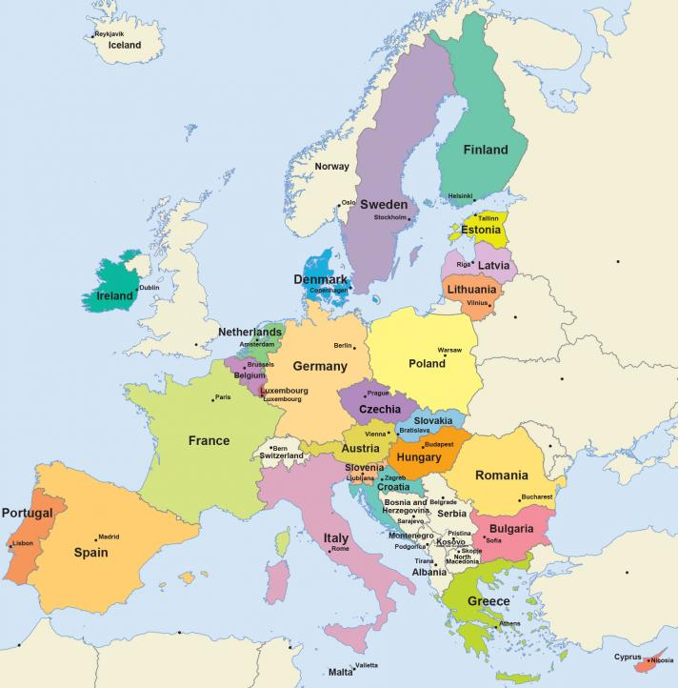

Geography

KS3/4G005

Continents

Learner Name:
Date Started:
Date Completed:

Tutor Name:
Tutor Feedback:
……………………………………………………………………………………………………………………………………………………………………………………………………………………………………………………………………………………………………………………………………………………………………………………………………………………………………………………………………………………………………………………………………………………………………………………………………………………

The globe is divided into ……….. continents.
1)………………………………………………………
2)………………………………………………………
3)………………………………………………………
4)………………………………………………………
5)………………………………………………………
6)………………………………………………………
7)………………………………………………………
Label them on the map below:

Use the table below to show the population of each continent:
CONTINENT | POPULATION

Can you name any seas or oceans?
…………………………………………… …………………………………………..
…………………………………………… …………………………………………..
…………………………………………… …………………………………………..
Label them on the map below:

Use the table below to link some countries that are on each ocean/sea:
Sea/Ocean | Nearby Countries

ACTIVITY – On a blank map
- Label as many countries as you can
- Label as many capitals as you can
- Label as many seas/oceans as you can

