KS3 Initial Assessments

Reading Score:

Put correct grammar in the following sentences:
Bobby’s pen was on the floor

Megan and Hugo went to the park even though it was raining to play with the ball.

Sarah said do you want anything from the shop.
Tell us about who you live with and where you live:
……………………………………………………………………………………………………………………………………………………………………………………………………………………………………………………………………………………………………………………………………………………………………………………………………………………………………………………………………………………………………………
Can you think of any words that rhyme with;
Blue ……………………………………………………………………….
Sea ……………………………………………………………………….
Ball ………………………………………………………………………..
Car …………………………………………………………………………

Put the correct maths symbols in the following sums:
4 5 = 9 8 2 = 6 4 3 = 1 9 3 = 12

5 2 = 10 6 2 = 3 8 4 = 2 3 3 = 9

Name the following shapes:

…………………….. …………………… ……………………. …………………..

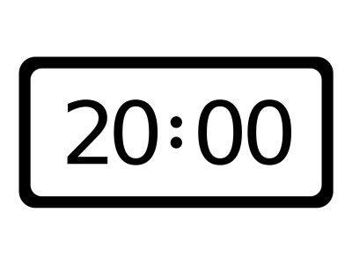
What time is on these clocks:
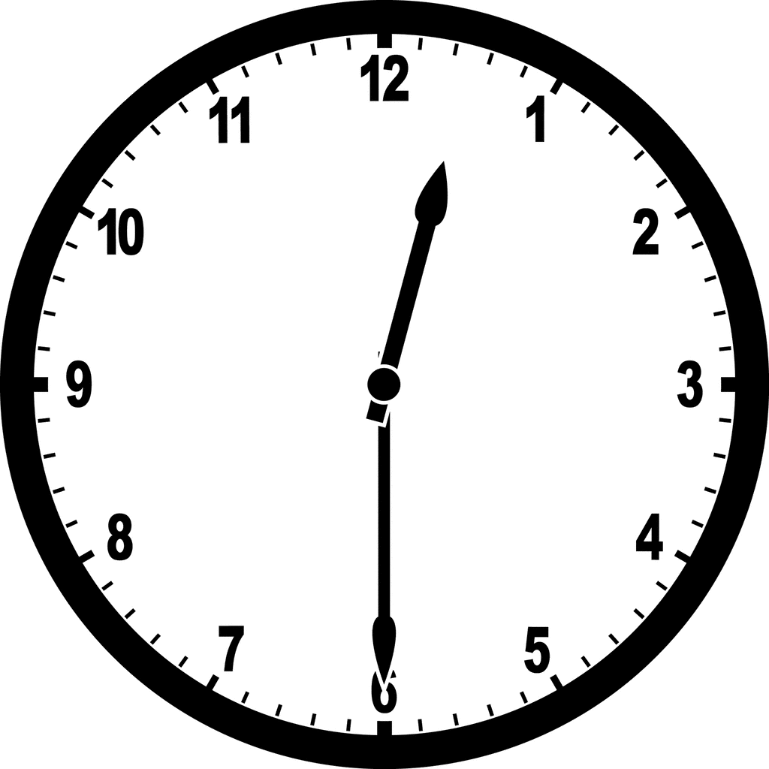
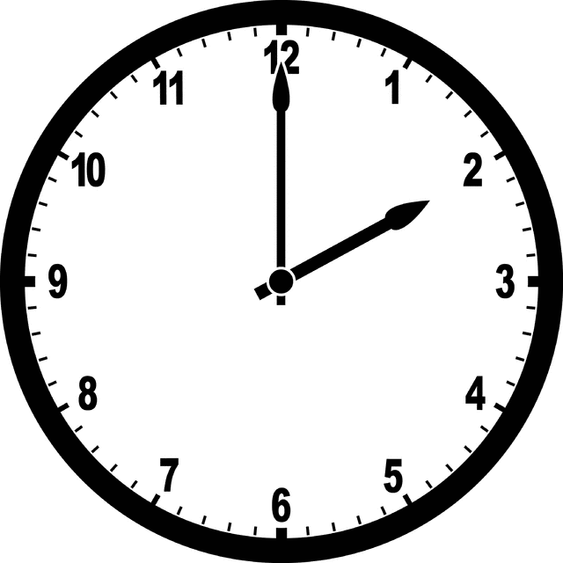
………………………. …………………………. …………………………

Add the following amounts together:
£5 + £10 = ………………
£10 + £2.30 = ………………
£20 + £7 + £1.25 = ……………….

How many Centimetres wide is your page? (use a ruler)

…………………cm

