Induction
Pack

Policy Title
Induction Pack
Version Number | 1.2
Policy Implementation Date | 01 AUG 2021
Peregrinate Policy Manager | Angela Mollan, Chris Mollan
Approved by Senior Management | 01 AUG 2021
Approving Signature | Angela Mollan
Policy Review Date | 01 JUL 2024

Welcome

Welcome to your training with Peregrinate Ltd.

We aim to provide training and develop skills in a vocational context, alongside academic qualifications:

- ICT

- Maths

- English

- Science

- Retail

- Work skills

It is our sincerest wish that you enjoy your programme whilst you are with us and that you succeed not only in gaining your qualifications, but go on to be successful in your chosen career.

We will undertake to do whatever we can to make your learning experience a varied and enjoyable one. Your wellbeing is our primary concern and we want you to feel that you are able to talk your Tutors should you have any concerns, which affect or interfere with your training.

During your induction your Tutor will make you aware of what is required of you in relation to your training and what you should expect from us as your training provider.

You will be provided with information relating to Law, such as Health and Safety and Equality & Diversity, which are of vital importance in what we do, whether at work or not.

Your Tutor will be available to provide you with advice and support throughout the programme.

Peregrinate Ltd Contact Information

We are located at:

Lifestyles Centre
Altcross Road
Croxteth
Liverpool 11

Telephone: 07952206846

Email address info@peregrinate.co.uk

Mission Statement

To provide bespoke, personalised education, training and consultancy services that will represent the best value for money using innovative teaching and learning strategies - leading to positive impacts on an individuals’ and the companies’ productivity and performance.

Peregrinate Ltd Access Statement
Peregrinate Ltd is committed to providing training and development which is accessible to all. We recognise everyone has different needs and will endeavour to accommodate these where needed.

Peregrinate Ltd will arrange alternative venues and training methods as required.

Learning reviews

Peregrinate Ltd recognises the importance of reviewing your progress towards the achievement of your objectives, as agreed in your Individual Learning Plan. The review will be used to:

- Identify additional learning and support needs
- Resolve problems
- Set new targets
- Plan and co-ordinate on and off site learning activities
- Provide feedback on progress to date

You will have a tutorial session every week and your progress will be reviewed regularly. A review meeting will take place every four to six weeks.

The review meeting will provide the opportunity for all involved in your programme to participate and comment on your progress. Your Tutor will manage the review meeting and record the discussion using the Individual Learning Plan.

The review will consider the following:

- Progress towards meeting previously agreed action points
- Progress towards meeting the learning and development plan
- Outcomes of planned assessments
- Learning and support needs
- Problems and unresolved issues
- Potential obstacles to achievement
- Health and Safety issues
- Equal & Diversity issues
- Safeguarding issues
- Amendments to the ILP
- Moving on and continuing to develop your skills, Peregrinate Ltd will support you in deciding your next step.

Peregrinate Ltd has a quality assurance system to ensure that the review process is meeting its objectives. This will include:

- Ensuring all staff are trained in carrying out reviews and completing documentation
- Checking quality of completed documents and implementing corrective action
- Observing staff carrying out reviews
- Reviewing documentation and policies annually

Equality and Diversity

Peregrinate Ltd is committed to Equal Opportunities for everyone.

Peregrinate Ltd Commitment:

- As learners you should feel comfortable and safe in your learning environment

- There is a Grievance Procedure to be followed if anyone feels unfairly treated

- The policy is supported by all at Peregrinate Ltd and will be reviewed and monitored every 6 months

As an employer or training provider the Law says we cannot discriminate or treat learners or employees differently.

Safeguarding

What is Safeguarding?

Safeguarding is something that Peregrinate Ltd is committed to and it applies to all staff and learners. Peregrinate Ltd and its partners will ensure that the Safety of Learners is taken into consideration when recruiting staff. We will also encourage the raising of awareness of Safeguarding by equipping learners and young adults with the skills needed to keep them safe, and provide an environment in which learners can learn and develop.

Peregrinate Ltd will also make sure that:

- It will establish and maintain an environment where learners feel secure, are encouraged to talk and are always listened to
- Ensure learners know who the adults in the organisation are who they can approach if they are worried
- Develop effective links with relevant agencies and co-operate as required with their enquiries
- Keep written records of concerns raised by learners, even where there is no need to refer the matter immediately.
- Ensure all records are kept securely; separate from the main learner file, and in a locked location
- Develop and then follow procedures where an allegation is made against a fellow learner, member of staff or associate
- Provide a Safeguarding Officer who is trained and able to assist with any raised issues.

What would you do if you think a child or young person is being abused?

https://www.gov.uk/government/uploads/system/uploads/attachment_data/file/419604/What_to_do_if_you_re_worried_a_child_is_being_abused.pdf

If you need help or advice you can contact Careline (Liverpool City Social Care Call Centre) Staff are available 24 hours a day of the year, providing a central contact point for enquires or advice:

0151 233 3700 for Careline Children’s Service (aged 14-18)
0151 233 3800 for Careline Adult Services (aged 18 years and over)

Or by email at wecanhelp@liverpool.gov.uk

Peregrinate Ltd Learner ICT Policy

You are responsible for following Peregrinate Ltd ICT Policy. This policy includes the use of internet, E-mail, mobile or smart phones with text and/or web browsing functionality.

The internet is available for you when you are doing research and accessing information. You will be provided with log in details and are requested to act in a responsible manner. Peregrinate Ltd may review files and communications at any time. This may include internet, emails and instant messaging. All monitoring, surveillance or investigation activities are conducted by authorised ICT staff and comply with the Data Protection Act.

Social networking sites will be banned to minimise abuse risks to you and other learners.

Any misuse of the system will be treated seriously and may result in disciplinary action.

Internet Safety Guidelines

- Never give out your personal details without checking the reason why it is needed
- Meeting someone you have only been in touch with online can be dangerous, tell an adult or a friend/family and don’t do it alone
- Be aware that people may not be who they appear to be on-line
- Never send photos of yourself to anyone on-line, especially in response to a direct request
- Trust your instincts. If someone is sending you email or chat requests that make you feel uncomfortable, tell a member of staff
- Learn how to block or ignore people
- Don’t reply to abusive messages. Learn how to keep an archive and save conversations

Zero Tolerance commitment

- By using the ICT systems at Peregrinate Ltd I agree not to access any material which is obscene, racist, illegal or causes harassment to others.
- I will not let my words or actions hurt others.
- I will report any incidents that I feel breeches the above policy.

Name: ___________________________ Date: _____________________________

Signature: __________________________________________________________
Mind Map Activity

Assessment

Candidate disagrees with the Assessment decision
Assessor explains
the reasons & the
Candidate Agrees
Candidate disagrees
Assessor
Internal Verifier
Candidate disagrees with Internal Verifiers decision
Candidate can appeal to the
Awarding body appeals Tribunal
Candidate Agrees with Assessment decision
Candidate can appeal to the
Awarding body appeals board
No further
Action
Candidate can ask for a review
of the assessment by contacting
the Awarding body
Candidate disagrees
With Review Process
Candidate disagrees
with the Appeals Board

Write the name of your Assessor/Tutor here: ___________________________________

Write the name of your Internal Verifier here: __________________________________

Write the name of the Awarding body EV here: _________________________________

Candidate Name: ________________________________________________________________________________

Appeals Procedure

Grievance / Complaints Procedure

Learner has a problem

Learner to discuss the problem
with their Tutor
Tutor to review the
situation
Problem resolved by all three people involved
Tutor unable to resolve situation
No further action
Learner to discuss the problem with the 14-19 Manager
Problem with Tutor
Refer problem to Quality Manager

What to do in the event of a Fire

Peregrinate Ltd have adopted a fire marshal and warden system in the event of a fire emergency. These persons will be responsible for the safe and swift evacuation of persons using our facilities.

In the event of a fire the following procedures should be followed:
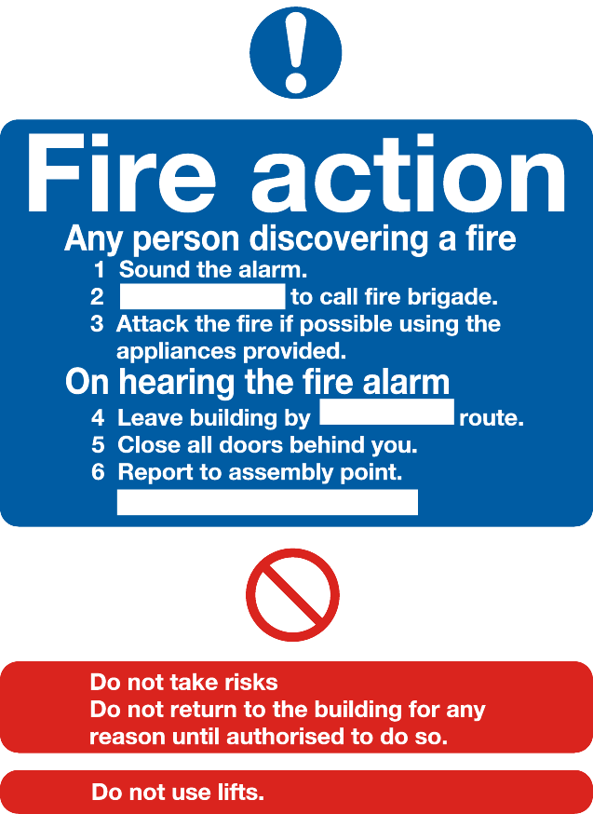
- Raise the alarm verbally and on exiting activate one of the break glass points.
- Evacuate the premises using the safest and nearest route to the front of the building, do so calmly and safely and make your way to the area in front of the ‘drop box’ and await further instruction.
- Assemble in your assigned group and await the call of your register.
- Ensure your name has been called or make yourself known to the register caller
- Do not re-enter the building or leave the register call area unless given authorisation to do so.

Things not to do:
- Do not use the lift in case of a power out type situation
- Do not push or pull against people when evacuating
- Do not stop to collect belongings
- Do not prop open doors or open windows
- Do not attempt to tackle the fire using the firefighting equipment
- Do not fool about as this can cause further health risks

Things to do:
- Ensure your actions do not endanger yourself and others
- Close doors and windows on the evacuation route to limit smoke and oxygen which can feed the fire
- Evacuate calmly and safely
- Assist others if they are struggling or require help
- Follow all directions given to you by your tutor or fire officer
- Report any fire risks or safety concerns

What to do in the event of a first aid situation:

Procedure

In the event that you or someone else is injured and require first aid please call for help immediately and a first aid person will be called to assist the injured party.

Reporting and recording

All accidents regardless of the severity have to be reported so please ensure that a report is made as soon as possible. This can be done through your personal tutor. Please provide as many details as possible concerning the event as this information will be important in ensuring swift action is taken to prevent further incidents.

Medical concerns

It is our duty to ensure the health, safety and welfare of all persons who use our facilities. As such it is important that you let us know of any specific medical needs so that we can establish a safe environment for you to learn in. If you have any specific medical requirement/s or needs it is very important that you inform your tutor as soon as possible. In certain circumstances we may be required to carry out a risk assessment on you and your medical condition to ensure that we can provide the required level of care or provision of care should you require it.

Some examples of medical conditions requiring reporting (If unsure please ask your tutor):

- Heart problems or breathing related problems such as asthma
- Diabetes,
- Blood disorders
- Fits or seizures

Suggestion Scheme
My Suggestion is:

My contact details are:
Name
Email:
Phone:

INDUCTION CHECKLIST

Learner Name: __________________________________________________________

Content: Yes No

1. Information on Peregrinate Ltd

2. Course Information

3. Detailed Timetable

4. Course Delivery

5. Personal Tutorial and Reviews

6. Grievance and Complaints

7. Appeals Procedure

8. Suggestions

9. Health and Safety

10. Equality & Diversity Activities

Tutor Signature:

Learner Signature:

Date:

